Rotary Disc Filter
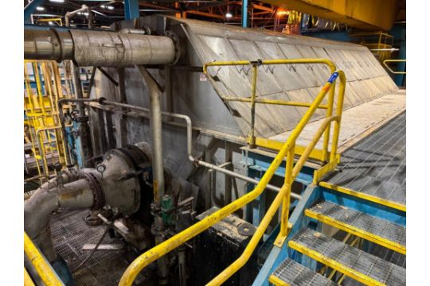
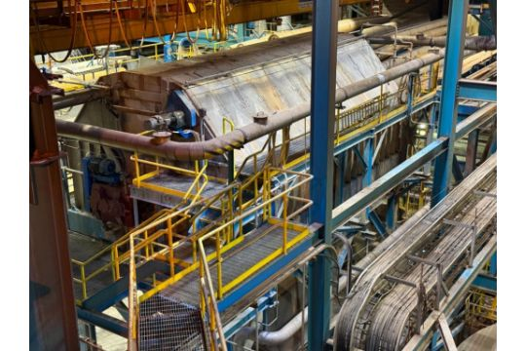
Hedemora Rotary Disc Filter, Model 5. 16/22, 316ss, 18' Dia x 30' Long [LOCATION: STK PREP OPERATING FLOOR]

