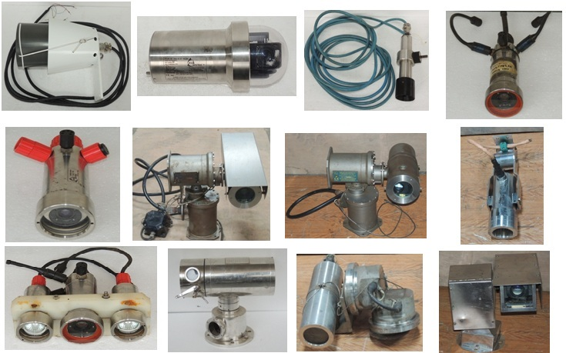

OVER ALL CAMERA :
Eca HYTEC  Explosion proof panoramic viewing color TV camera  DTR 100 Z ADF | 10x zoom and tilt / rotate viewing head for panoramic viewing  Certified EEx d llC T6 according to ATEX 94/9/EC directive. Other certifications : see data sheet  compact (ø 120 mm - L 265 mm) | 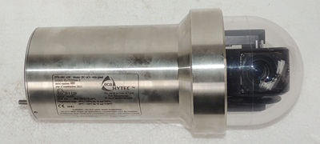
Eca HYTEC  TV Explosion Proof  Multiplexed COLOR  CCTV SYSTEM  MODEL  DTR100 ZADFM | W/ SWIVEL HEAD AND ZOOM CAMERA  ||2G/D Ex d||C-40/+100`c  PT B00ATEX 1059  ISO M20 | 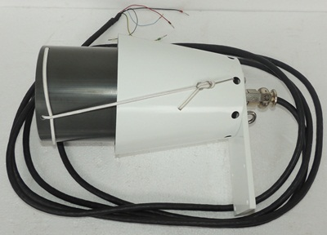
Eca HYTEC  Smart color TV camera  VS 3673 | -PAL or NTSC video signal  - OD 75 mm ; L 145 mm  - Controlled by RS 232 serial link or by analogic mode  - Operating depth : 1 000 meters  - Stainless steel housing | 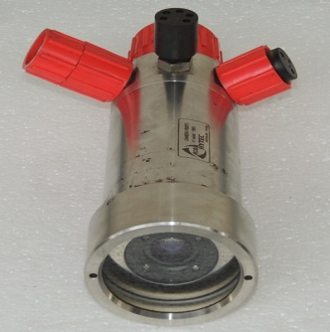
HY 9806900 |  | 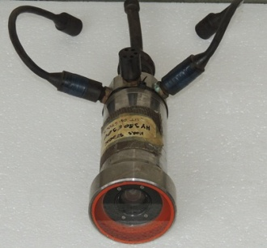
Eca HYTEC  Smart color TV camera with 10x zoom  Underwater halogen light  VS 3673 | -PAL or NTSC video signal  - OD 75 mm ; L 145 mm  - Controlled by RS 232 serial link or by analogic mode  - Operating depth : 1 000 meters  - Stainless steel housing  Also available in 3 000 meters version | 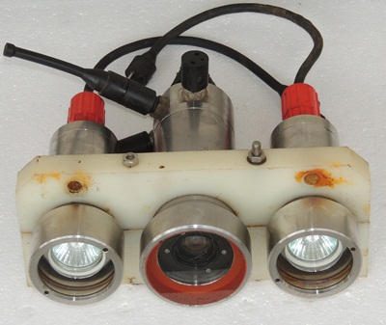
HYTEC Camera  VS 662 ADF | VS 662 ADF EEx d ||C T4  INERIS 93.C.5062 X  0` de fabrication 004  P max 8.5 Watts Umax 14 VAC  NE PAS00VRIR SOUS TENSION | 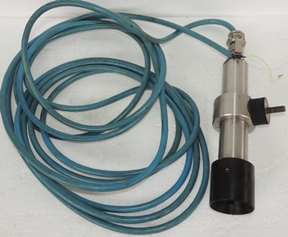
HERNIS Scan System  optical magnification superseding typical compact cameras with 36X zoom CCTV Camera  Ex 285 PT | ARENDAL NORWAY  NO – 229  EEX de ||C T6 IP 66  Certificate no Ex 960311 | 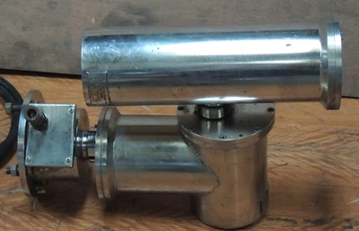
HERNIS Scan system  Ex proof Camera Stations HERNIS dedicated CCTV control panel, video wall, OEM HMI (e.g.drillers chair), Ex monitors, touch monitors and mobile units. 8. Control  Ex 286 | S No .1256 CE 0575 EX ||2 6  EEx de ||C T6 IP 66  Umax : 40 VAC 50/60 Hz iMAX : 4A  Prod Year - 2006  Certificate no -  DNV – 2003-OSL-ATEX-0366  IEC Certificate no –  IEC EX DNV 06.0002  Ex DE ||C T6 IP 66 | 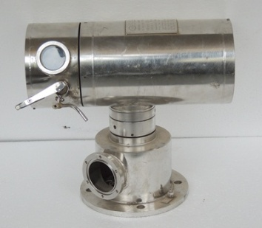
HERNIS offers a well proven range of CraneTV systems meeting the requirements of Crane operators worldwide the joystick or push button controls. An oil damper keeps the camera housing in a stable vertical position  Ex 291C | S no - 30559 CE 0575 Ex || 2G  Ex d ||C T6 IP 66  Tamd = 50`c +60C  Pred Year - 2012  Certificate no -  DNV 2003-OSL AT EX -0013X  IEC Certificate no -  IEC Ex DNV – 06 .0003x | 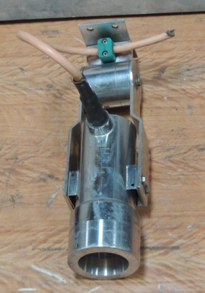
HERNIS Modular design  Internal cabling  Integrated junction box  Flexible mounting  Electro polished stainless steel 316L  Robust gearbox  Electro-mechanical brakes on shaft  PT36W | Material: Stainless steel  Surface: Electro polished  Pan speed: 0-40/sec  Tilt speed; 0-20/sec  Equipment: Receiver, Washer/ Wiper  1/3" NTSC / PAL camera, High Resolution, 10 x or 15 x zoom lens, can be controlled from HE 250/ HE 400  Approval: IP66 | 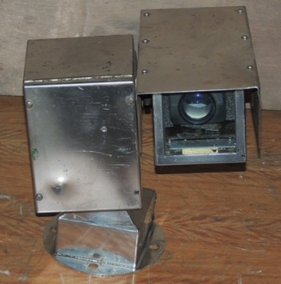
ELSHAM WOLD SRIGG  FEH-B-1 | EEx d || B T6  BASEEFA CERT NO  Ex 88B 1253  VOLRS 230 AC 50Hz  MAX POWAR - DISSPATI ON. 11.5  S. No. - 2558 | 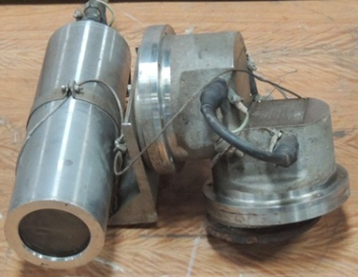
Electro-flow Controls LTD  EFC GROUP TYPE 556 CAMERA HOUSING CAN BE SUPPLIED AS EITHER A STAND ALONE HOUSING OR A COMPLETE ASSEMBLY WITH CAMERA, LENS, SUNSHIELD AND GLANDED CABLE TAIL. CAMERA UNIT  556 | S. NO. - 211032  Overall Weight 12kg  Ingress Protection - Rating IP66  Temperature Rating - -20°C to 60°C  Heater / Thermostat - 110/240VAC, 50/60Hz 15 Watts  ITS .10ATEx 1696X / IECEx Its 10.0029X | 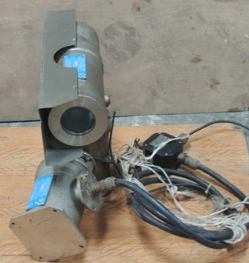
Electro-flow Controls LTD  EFC GROUP TYPE 556 CAMERA HOUSING CAN BE SUPPLIED AS EITHER A STAND ALONE HOUSING OR A COMPLETE ASSEMBLY WITH CAMERA, LENS, SUNSHIELD AND GLANDED CABLE TAIL CAMERA UNIT  556 | S. NO. - 29016  Overall Weight 12kg  Ingress Protection - Rating IP66  Temperature Rating - -20°C to 50°C  Heater / Thermostat - 110/220VAC, 50/60Hz 15 Watts  Demko – 03A Tex 135182 | 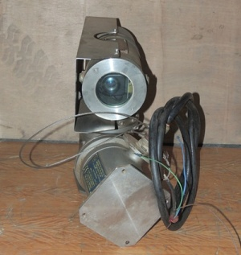
Electro-flow Controls LTD  THE 558 PAN & TILT IS AVAILABLE IN THREE MODES; PAN ONLY, TILT ONLY AND PAN & TILT. THE ASSEMBLY IS FOR INTEGRATION WITH EFC GROUP 556 CAMERA HOUSING AND THE 557 WIPER UNIT.  558 | S. NO. - 21026  Overall Weight 30kg  Operating Temperature Ambient -20 to +60°C For Colder Operating Temperatures in the Range of -40°C to -20°C,  Standard Power Requirements 110v/240VAC, 50-60Hz  Rated Consumption 50 Watts  Ingress Protection IP66  Certification ATEX & IECEx  ITS .10ATEx 1696X / IECEx Its 10.0029X | 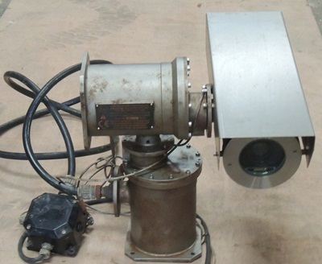
Electro-flow Controls LTD  THE 558 PAN & TILT IS AVAILABLE IN THREE MODES; PAN ONLY, TILT ONLY AND PAN & TILT. THE ASSEMBLY IS FOR INTEGRATION WITH EFC GROUP 556 CAMERA HOUSING AND THE 557 WIPER UNIT.  558 | S. NO. - 211028  Overall Weight 30kg  Operating Temperature Ambient -20 to +60°C For Colder Operating Temperatures in the Range of -40°C to -20°C,  Standard Power Requirements 110v/240VAC, 50-60Hz  Rated Consumption 50 Watts  Ingress Protection IP66  Certification ATEX & IECEx  ITS .10ATEx 1696X / IECEx Its 10.0029X | 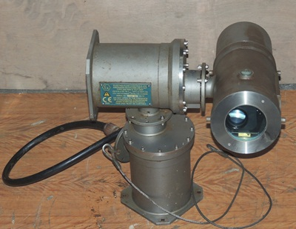
Electro-flow Controls LTD  THE 558 PAN & TILT IS AVAILABLE IN THREE MODES; PAN ONLY, TILT ONLY AND PAN & TILT. THE ASSEMBLY IS FOR INTEGRATION WITH EFC GROUP 556 CAMERA HOUSING AND THE 557 WIPER UNIT.  558 | S. NO. - 210034  Overall Weight 30kg  Operating Temperature Ambient -20 to +60°C For Colder Operating Temperatures in the Range of -40°C to -20°C,  Standard Power Requirements 110v/240VAC, 50-60Hz  Rated Consumption 50 Watts  Ingress Protection IP66  Certification ATEX & IECEx  ITS .10ATEx 1696X / IECEx Its 10.0029X | 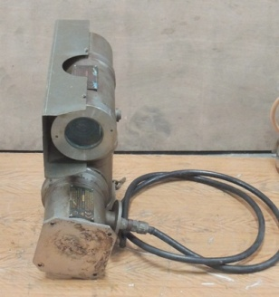
The Kongsberg Maritime model oe1324 Enhanced SIT camera combines the proven  underwater  pressure housing with 3,000 metre depth rating as standard  (other housing options available). The standard camera includes  adaptive contrast enhancement, automatic tube protection  circuits, over-voltage protection, and special high-frequency  most successful range of professional underwater cameras.  OE 1367MKll | Water Depth 3,000 metres, deeper options available  Temperature Operating -5°C to +40°C  Storage -20°C to +60°C  Vibration 10g, 20 - 150Hz, 3-axes (non-operating  Size Diameter 102mm exc. guard Length 297mm exc. connector Weight Air 4.6 Kg Water 2.2 Kg Standard Housing 6Al/4V ASTM B 348 Titanium Alloy  Signal to Noise >40dB weighted (AGC off)  Scanning 625 Line / 50 Hz CCIR  525 Line / 60 Hz RS-170 (optional)  Power Input Constant Voltage 16V - 24V dc,  Model OE 100 | 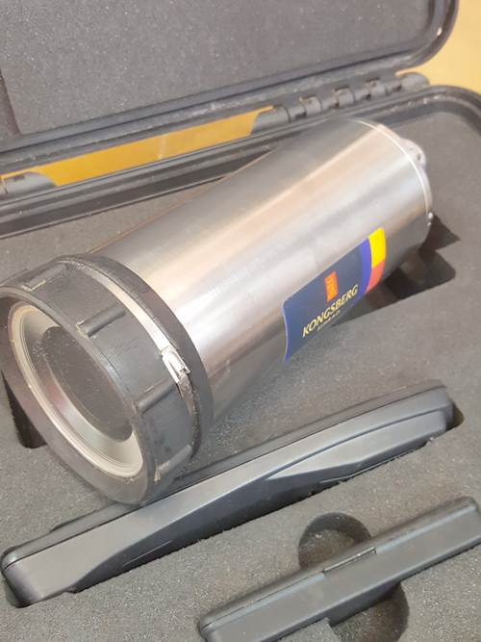
The Kongsberg Maritime 14-366-0694Colour Zoom Camera is our industry standard ROV inspection camera. This camera uses the latest super HAD CCD technology to give improved light sensitivity and image definition. The standard depth rating is 4,500 msw.  14-366-0694 | Dimensions Diameter: 88mm  Length: 210mm (excl. connector)  Weight In air 2.6Kg, in water 1.44Kg  Housing Material Titanium Alloy, 6AL/4V ASTM B3 48  Operating Depth 4,500 msw (other depth rated housing options available)  Temperature Operating: -5 to 40°C, Storage: -20 to 60°C  Shock 30G peak acceleration, 25ms half sine duration, on all three axes  Vibration 10G, from 20 to150Hz on all three axes | 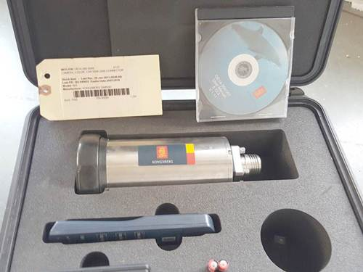
The Kongsberg Maritime  Seahawk Integrated colour Television System  Surface control unit  OE 1260A | Temperature Operating 0°C to +40°C  Storage -20°C to +60°C  Vibration 10g, 20-150Hz, 3-axes (non-operating)  Shock 30g peak, 25mS half-sine pulse  Mechanical  Width 442mm (17.4”)  Height 443mm (17.4”)  Depth 480mm (18.9”), 392mm (15.4”)  Weight 30.0Kg | 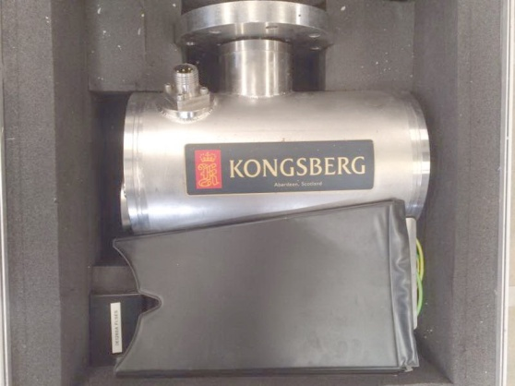
Technor as  TNCN-121009 | Certification ATEX & IECEx  Demko - 86-80151  Nemko - 83036  S/N - 10976 | 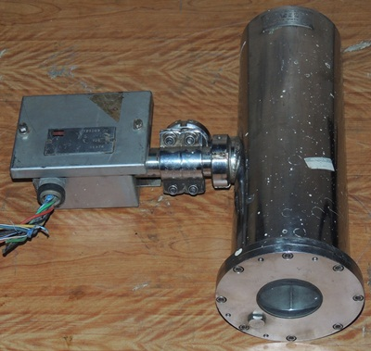
ROES  06 081606Ex | P/N – 495069  Max.: 4 mm2  Nom.voltage – 120V  EEx e ll T6 Ex | 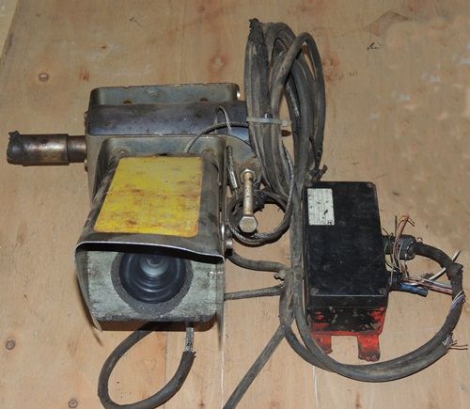
Remote Ocean System  Spectator TI NTSC Bipolar  52-26900-A01 | 2 Pcs | 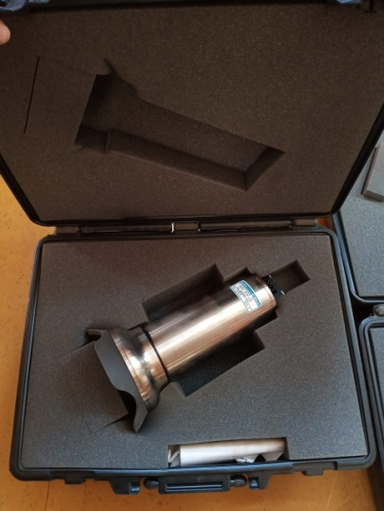
Remote Ocean System  Low Light B+W CAM 1500 m ETA  52-23813-01A |  | 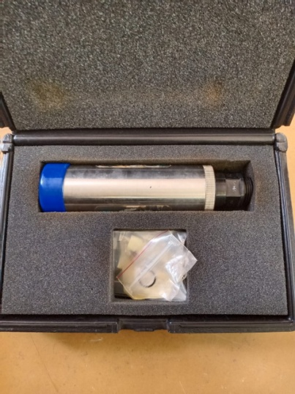
Remote Ocean System  Navigator TI 3 KM ETA LOC LIA  52-24922-AT06 |  | 