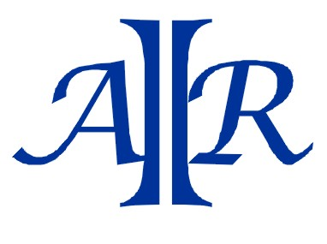
John Leigh
+61 (0) 403574225
johnl@assetinvest.com

"DE SMET" SOLVENT EXTRACTION PLANT AND "FRENCH" DESOLVENTIZER
Following is a listing of some of the equipment that comprises the solvent extraction plant and the desolventizer that we are offering:
- Seed Preparation Equipment for capacity of 80 MTD
Bucket Elevators
Screw Conveyor to Silo
Seed Cleaner and Blower
Hammer Mill for Hulls
Hammer Mill for Oilseeds
Vertical Cooker
8" Anderson Extruder
Redler and Belt to transport cooled cake

- "De Smet" Solvent Extraction Plant for capacity of 45 MTD
Extractor
Screw Conveyors

- Bagging Equipment
Rotex
Cake Mill
Belt

- Water Cooling System
Cooling Tower
Hexane Pumps

- "French" Desolventizing Equipment
Hexane Evaporator
Dowtherm
Hexane Fan
Gas Scrubber Cycle
PRICE "AS IS, WHERE IS" USD$ 285,000
Note: Currently the plant is not in operation. Plant is available for inspection and review.
Videos available

