Tile Sheet line consisting of Decoiler 7,5 Ton – Rollforming Machine – Hydraulic Press – Shear – Automatic Stacking Table – Conveyor – Operation Equipment

Note: adjustable step length and step depth as shown on three profile drawings below.

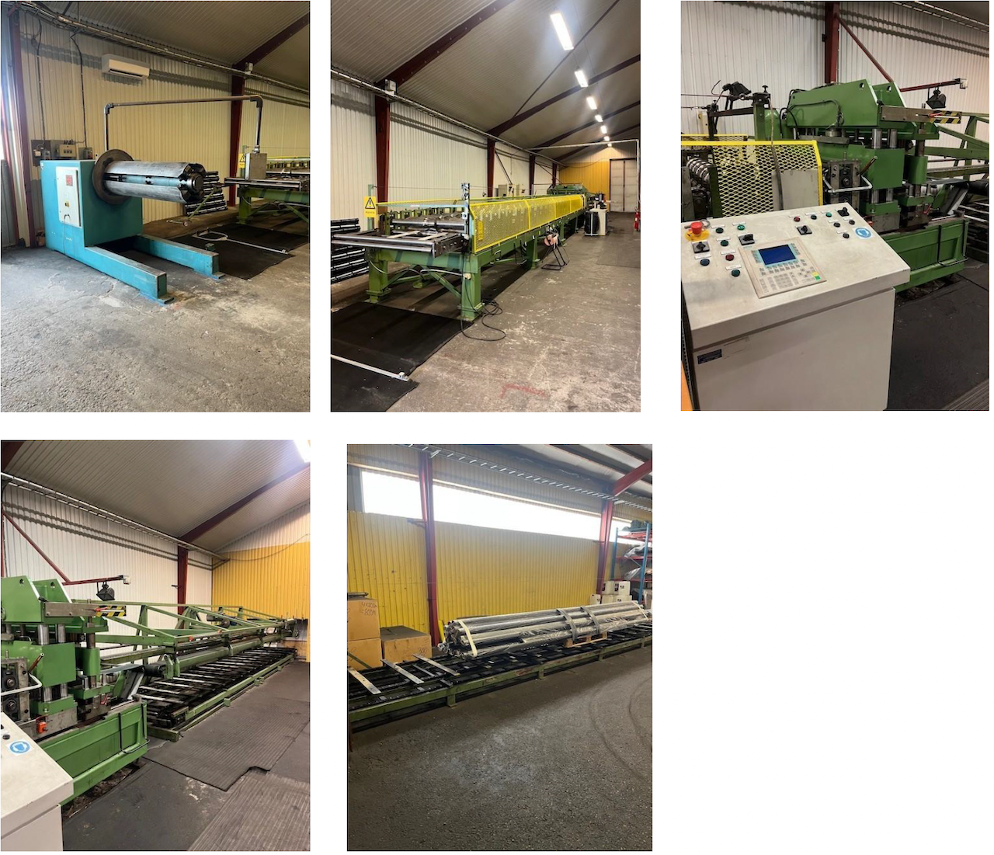
TECHNISCHE SPEZIFIKATIONEN
Stärke: 0.5 - 0.6 mm
Deckbreite: 1050 mm
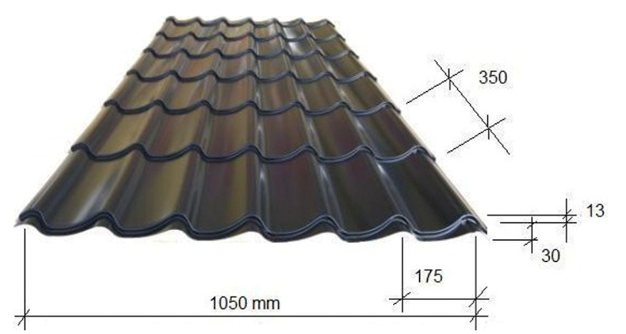
Profilhöhe: 30 mm



