T O ：lion@akino.co.il FROM: sales@superdamachine.com
ANNT：Lion Levy, TEL：+86 188143555377
TEL ：972 54 232 2632 FAX：
FAX ： Contact: Demi
SPD-C2018 ultrasonic cleaning machine technology agreement
I. Overview:
Second groove Gas ultrasonic cleaning machine for the hardware characteristics of the design of ultrasonic cleaning equipment. The main imported high-quality parts and materials imported SUS304 # stainless steel production and processing, production. At the same time using the most advanced ultrasonic frequency circuit, Fm-3 FM technology, integrated design, module output power, stable, reliable, low repair rate. Brown also designed the amount lockout, over-current shutdown protection, three micro-power soft-start, frequency automatic tracking, LED power and frequency display. Having a good cleaning quality, high production efficiency of operating advantages. Equipment consists of ultrasonic cylinder, ultrasonic shock sub, heating, temperature control system, filtration sprinkler systems, air conditioning systems, electrical control and so on.

Second, the cleaning principle:
Ultrasonic wave generated by the ultrasonic transducer vibrations per second to tens of thousands of times in the liquid conduction, since the broadcast is a compression ultrasound longitudinal wave, causes the liquid pressure changes produced countless tiny vacuum bubbles in the media to promote its role in causing cavitation (CARIATLON). Present in the liquid micro-bubbles (cavitation nuclei) vibration under the action of the sound field, when the sound pressure reaches a certain value, the bubbles will quickly become large, then suddenly closed, shock waves when the closure of the bubbles produced can generate around it thousands of "atmospheric" pressure, leaving them destroy insoluble dirt dispersed in the cleaning solution.

Third, the cleaning process:
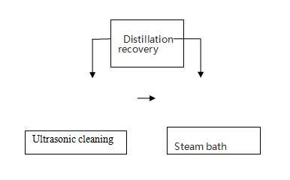

Four, SPD-C2018 ultrasonic cleaning machine is mainly composed of materials and functions:
1, the ultrasonic generator:
①, ultrasonic bath with an ultrasonic transducer. Ultrasonic transducers used in Taiwan to Nanjing vibrator head.
②, ultrasonic bath containing 18 transducers, ultrasonic power 18PCS * 50W = 900W, frequency of 40KHz.
③, tank materials imported δ2mm Japan SUS304 # board production. Acid, anti-vibration, long service life.
④, Ultrasonic tank size: 405 * 355 * 405mm, steam bath Size: 405 * 355 * 405,
Dimensions: 1600 * 805 * 1270mm (L * W * H)
2,
①, cleaning tank has one set of filter circulation system. By the filter pump (the United States, "Little Giant"), stainless steel filters, stainless steel tubing and other components.
②, stainless steel filter (US Aqua-cleau) inside with 10μ filter cotton core.
3, piping systems:
①, cleaning tank with one set of loop filter line.
②, tank cleaning and bath wash each with a set of stainless steel drain valve.
③, all into the liquid, circulation, fluid line with SUS304 stainless steel and brass components.
4, the temperature control system:
①, cleaning tank and steam tank with heating device, heating power 3Kw.
②Stainless steel heating pipe heating pipe (Taiwan, "Paul Long").
③, thermostat with South Korea "Lai Renbao" thermostat, adjustable temperature control range: room temperature ~ 100 ℃.
5, the refrigeration system:
- , using a set of 3HP US "Taikang" compressor
②, cold exhaust pipe with SUS316δ1.5 steel production.
③, equipped with a condenser, evaporator, dry filter, gas tank, an expansion valve.
④, with high and low voltage protection and overload protection.
6, The frame parts:
- , machine chassis with stainless steel flat-pole welding.
②, support parts etc. using stainless steel square pole.
7, Cylinder sections:
Third, the use of imported SUS304δ2.0 cylinder production.
Fourth, the head imported SUS304δ1.0 production.
8, electrical control
①, with separate electrical control box with the power supply on the control panel, ultrasound, heating, and other filter pump switches and lights.
②, with high and low voltage protection, motor overload protection.
③, electrical control components are made of high quality imported components.
Fifth, compared with the same industry, the advantages described:
1, the use of advanced ultrasonic generator frequency modulation circuit, the latest IC circuit technology, cleaning time can be shortened to improve the cleaning effect.
2, using the latest power module, the electrical box of safety and service life greatly improved, can effectively protect the normal operation of the ultrasonic head.
3, light-emitting diode display size of the vibration frequency.
4, soft-start circuit to reduce the startup current transducer head impact, vibration head prolong life.
Remark: （1）It will be with spray gun & tube, and pump
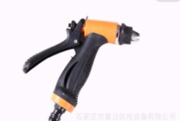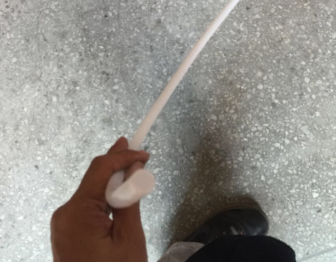

(2) This equipment is suitable for cleaning material * FLO ZT-DATA SHEET-MSDS and * Solkane 141B DATA SHEET-MSDS

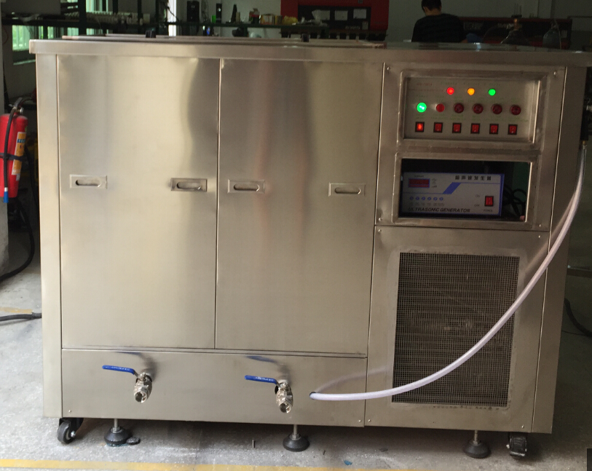

SPD-C2018 Item ,Equipment Photo just for reference

