About Hydraulic Rod Pumps, Intl.
Hydraulic Rod Pumps, Intl., founded in 1987 in Placentia CA is a world leader in hydraulic rod pumping technology. For over 3 decades, we had been focusing and developing the world's most durable and advance rod pumping equipment. Our technology & equipment is field proven and had been highly successful in delivering ultra-reliable performance for producers worldwide.
Today's volatile energy markets have prompted producers to demand the latest available technologies, higher electrical efficiencies and more reliable products from vendors across the board. Requests of this nature have become the new standard throughout today's E&P supplier marketplace, as producers prepare for an unpredictable revenue stream. Artificial lift is the primary tool for generating revenue and the largest area of expense for producers, so it has become the primary focus for maximizing efficiency and equipment longevity.

Ultra-long-stroke sucker rod pumping units entered the scene in the 1970's, as prototype experiments. They've emerged in the last decade as one of only a few quantum leaps in artificial lift technology throughout the entire history of sucker rod lift. This technology has quickly become the new standard, frequently chosen to solve problems, lift more fluid, reach out farther horizontally or go vertically deeper than any conventional beam unit can go.

How?
- Slower traveling speeds = reduced rod string fatigue.
- Near-fixed traveling speeds = lower rod string compression.
- Slower strokes per minute = reduced traveling/standing valve wear.
- Longer stroke lengths = higher compression ratios, which helps reduce gas locking.
- Longer stroke lengths = better mechanical efficiency (stroke vs. stretch ratio).
- Longer stroke lengths = longer tubing life due to longer coupling-to-tubing wear patterns.
- Ability to lift larger pump plungers = higher volume rate capacities.

HRP Hydraulic Cylinder
HRP International's Above Ground Hydraulic Cylinder boost the longest stroke length in the industry at up to 336 inches. The cylinder's advance sealing technology is also a world's first, installing directly above the pumping tee and eliminating the need for a stuffing box.
The Hydraulic Cylinder's construction is sturdy and light and don't require a pedestal on the well head for installation. Guide wires are not required to stabilize the cylinder. We use an optional tripod stabilizer to limit sway / harmonics.
The Hydraulic Cylinder also withstands high winds up to 60 knots and are installed in areas that experience cyclones and hurricanes. It is compatible for harsh produced fluids (acid, steam, condensate) and requires no special well head or adapters.

- Hydraulic Cylinder
HRP's above ground cylinder comes in a wide range of stroke lengths from 60 inches up to 336 inches. A piston connecting to the integrated polished rod is moved upwards (upstroke) by filling the cylinder with hydraulic oil. On the downstroke, the hydraulic oil is released from the cylinder and the weight of the rod string pulls the piston downwards.
- Hydraulic Fluid Intake
This is where the hydraulic hose is connected to move fluid in and out of the cylinder. Only the highest quality and most advance hydraulic fittings are used (similar to those found in the landing mechanism of planes and high-performance hydraulic components).
- Integrated Sealing System
HRP's above ground cylinder features a state-of-the -art integral sealing system that eliminates the need for a stuffing box. The proprietary and field proven design seals off the hydraulic cylinder from the wellbore fluid and vice versa.
- Wellhead Adapter
The wellhead adapter connects the hydraulic cylinder to the customer's wellhead and comes in many different configurations including API flanges, EUE 8RD connections and hammer unions. All of our cylinder comes preinstalled with the wellhead adapters ready to be attached to the existing wellhead connections.
- Integrated Polished Rod
The HRP cylinder comes with an integrated polished rod that is connected to the piston within the cylinder for ease of connection to the sucker rod string.
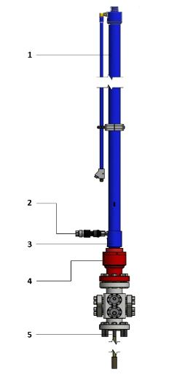

Long Stroke
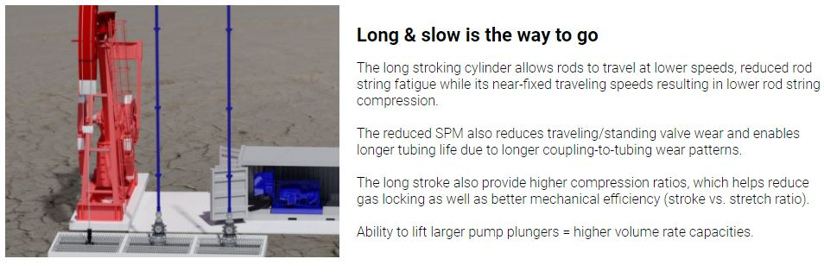
Integral Stuffing Box
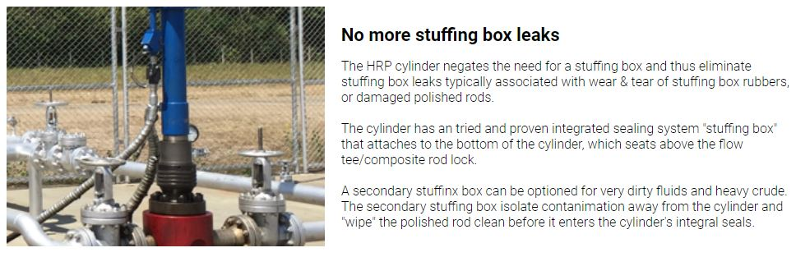
No Pedestal and Electricals
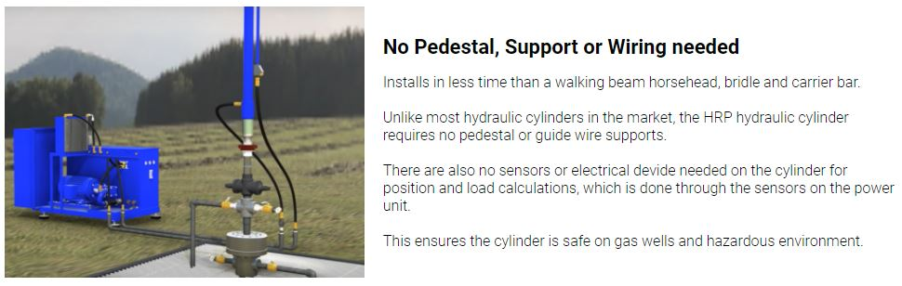

Lower cost for the higher production
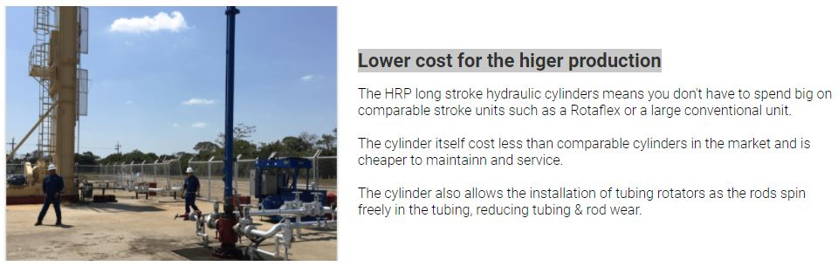

Specifications

Stroke Length
36, 60, 86, 120, 240, 336 (inches)
Cylinder Sizes
2.5, 3.0, 3.5, 4.0, 4.5. 5.0 (inches)
Peak Polished Rod Load (PPRL)
up to 53,376 lbs
Design Pressure & Temperature
design pressure 5000 psi
design temperature 150 deg C

