**Zeiss Atlas 9000**

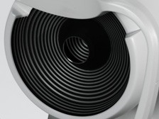

Patented Placido Disk Technology

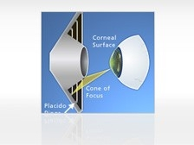

Triangulation with Cone-of-Focus, Placido rings, and corneal surface

**Placido Disk Technology with Cone-of-Focus Alignment System**

Proven, patented technology

* Patented Cone-of-Focus™ Alignment System and Arc-Step Algorithm deliver sub-micron elevation accuracy
* Using triangulation, the advanced ATLAS Arc-Step algorithm provides reliable surface reconstruction
* 22-ring Placido disk optimized to avoid ring crossover, which means reliable results for a wide range of patients
* Long, comfortable 70 mm working distance minimizes focusing error found in “small cone” systems

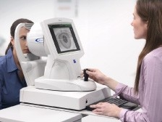

**SmartCapture Image Analysis**

Technology that helps your staff get the right image the first time

* SmartCapture™ analyzes 15 digital images per second during alignment and automatically selects the highest quality image
* Next-generation image processing provides more repeatable, reliable results, even in difficult cases
* Less dependence on operator technique means greater efficiency and fewer repeat exams

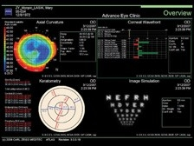

Assess higher-order corneal aberrations and simulate visual acuity

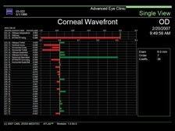

Optimize the selection of aspheric IOLs using Zernike corneal wavefront analysis

**Corneal Wavefront Analysis**

A valuable tool for patient education and treatment selection

Corneal Wavefront Analysis takes corneal topography to a new dimension. Using ray tracing technology, the Atlas displays higher-order corneal aberrations, providing valuable insight for patient education and treatment planning.

* Educate patients about higher-order aberrations and simulate visual acuity
* Assess corneal refraction with image simulation and point spread function
* Measure corneal spherical aberration with Zernike analysis to optimize the selection of aspheric IOLs
* View the effects of individual higher order corneal aberrations
* View changes in contrast sensitivity through the modulation transfer function (MTF)

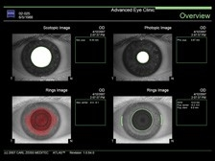

Scotopic and photopic pupil images

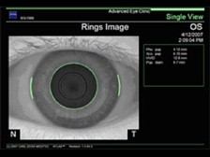

Automatic Horizontal Visible Iris Diameter (HVID) or “white to white” measurement simplifies the selection of contact lenses

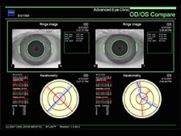

Easily measure and display HVID for both eyes with OD/OS Comparison Display

**Automatic Pupillometry and HVID Measurement**

Tools that enhance contact lens fitting and refractive surgery planning

* Pupil size, measured at two levels of illumination (scotopic and photopic @700 nm), provides insight into optical zone under varying light conditions.
* View centration of LASIK or orthokeratology treatment in relation to pupil center to assess treatment effectiveness
* Improve multifocal contact lenses selection by understanding patient's pupil size at two levels of illumination
* Streamline contact lens selection and fitting with automatic Horizontal Visible Iris Diameter (HVID) measurement

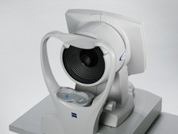



**Ergonomic Design**

Ideally suited for you and your patients

* Compact, integrated system with powerful computer and analysis software
* Unique chinrest positions patient for easy image capture and wide peripheral coverage and automatically detects OD/OS
* Non-visible Placido ring illumination is comfortable for even the most light-sensitive patients