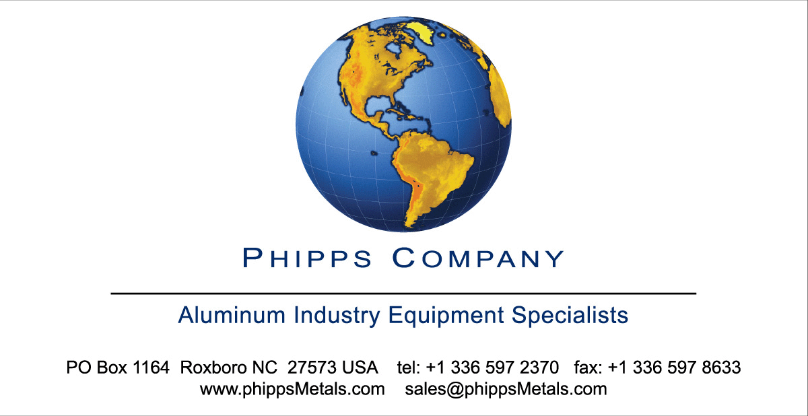
Henkel Chemical Spec Sheet for CC-157 offered by:

Line: “1”
Width: 66”
Speed: 300fpm Substrate: Aluminum

STAGE | 1 | 2 | 3 | 4 | 5
PRODUCT | PCL 305R | WATER | K702SLK/AC | WATER | WATER
TANK VOLUME | 3400 GL | 1550 GL | 2000 GL | 1300 GL | 1300 GL
DWELL AT MAX SPEED | 20 SEC | 3 SEC. | 6 SEC. | 3 SEC. | 3 SEC
TANK CONSTRUCTION | CRS | CRS | CRS | CRS | CRS
HEATING | PLATE | PLATE | PLATE | NIA | PLATE
MAX TEMP | 120-130 F | 120-140F | 100-120F | AMB | 140 -150  MAX
PRESSURE | 40 PSI | 40 PSI | 40 PSI | 40 PSI | 40 PSI
LEVEL CONTROL | HENKEL | HENKEL | HENKEL | HENKEL | HENKEL
REPLESNISHING PUMPS | YES | NO | YES | NO | YES
AUTODRAIN | HEADER | NONE | HEADER | NONE | NONE

TABLE OF CONTENTS

Section 1 Process Manual

Revision Date:  03/2006 | Stage  Stage 1 | Chemical Process  Parco Cleaner 305R
02/16/04 | Stage 2 | Hot Water Rinse
02/16/04 | Stage 3 | Bonderite K702SLK/AC
02/16/04 | Stage 4 | Cold Water Rinse
02116104 | Stage 5 | Hot Water Rinse
01122/09 | Stage 1 | Parco Cleaner 305R
01/22/09 | Stage 2 | Hot Water Rinse
01/22/09 | Stage 3 | Bonderite
 |  | K702SLK/AC
01122109 | Stage 4 | Cold Water Rinse
01122109 | Stage 5 | Hot Water Rinse

