MODELS DHW DHWS
HEAVY DIJTY DOWNSTROKE BALING PRESS
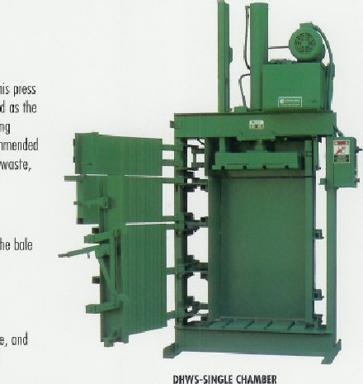
Sulidl'/ constructed 01 quality materials b'/ expert craftsmen, this press boosts Ill the extra features thot howe estohF15hed Consolidated as the worldwide leader in the Inunufoctwre of superior hydrauli( buling presses, Il','fillnhle in Single double chornber models Recommended for the duty bcling of wiping mgs, Clothing, textile towels, etc,
D*WS-SINGLE
Features:
- Retructuble End Doors-permit complete wmpping of the bole while ill the 5inre all four sides of bole exposed.
- Simpfified Controls-simple ditecticnol With pushbutton operation.
WASTE TECHNOLOGY CORPORATION
•Self Contained Unit-motor, pump, outumotic IBIief oll controls cre ntttthed to press—no pil 01 specinl foundation [equired.
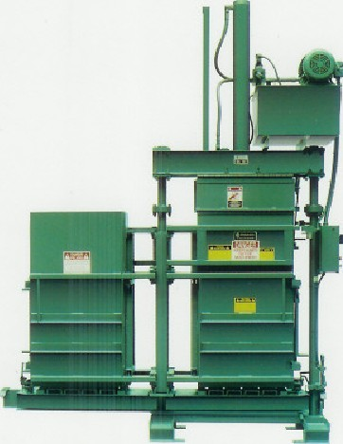
- UL Listed Panel-ensures the electlitfil panel meets today's quoliT,' stnnd01ds.
- Moveable Retainer Dogs (optional)-f01 Ille baling of fluff} motericls where multiple Imdngs and ctmpÆ5iijns are necessity.
DOUBLE CHAMBER DOWNSTROKE BALING PRESS Additional Features:
- Double Chamber-one chnrnbgr is IOCldgd while bole ill tie opposite (homher is compressed, 'Overed and lied. After removing the finished bole. the Chomhers ore revolved and the filled chomber is howght in position for compression. This operation saves time and
- Loading Options-permit loading of the the some the floc)' both.

DHW-DOUBLE CHAMBER

