1.0 PURPOSE
1.1 The purpose of this GMP is to train the Blown Film Line operators on the proper method of starting the line.
2.0 SCOPE
2.1 This GMP applies to all associates assigned to the Blown Film Line.
3.0 SAFETY
3.1 CPG is committed to safety. As the most important asset in the plant, our employees are expected to exercise due caution to protect themselves and their associates while working. The plant safety rules and proper apparel apply in the workplace at all times.
4.0 RESPONSIBILITY
4.1 The associate responsible for the area this GMP is used is responsible for ensuring that it is carried out per the enclosed methodology and recorded per applicable specifications and sampling plans.
4.2 It is also their responsibility to ensure that adequately trained individuals perform this method. This training can be delegated to a designated Area Trainer but is still the responsibility of the associate with area responsibilities. This training is required to be documented. Periodic refresher training is also to be provided and documented to assure standardization of methodology.
5.0 DEFINITIONS
5.1 None
6.0 REFERENCE
6.1 Figure 1 – Main Temperature Controls
6.2 Figure 2 – Main Drive Controls
6.3 Figure 3 – Main Drive Displays
6.4 Figure 4 - Bubble Air Control Valves
6.5 Figure 5 – Corona Treater Start
6.6 Figure 6 – Treater Electrode Switch
6.7 Figure 7 – Nip Pressure Regulator
6.8 Figure 8 – Bag Machine Start Control
6.9 Figure 9 – Seal Power Controls
6.10 Figure 10 – UV Control Console
6.11 Figure 11 – Print Squeeze Adjust
6.12 Figure 12 – Photo Eye Adjust
7.0 GMP
7.1 Clean up dies and apply release compound.
7.2 Verify the correct resins (as detailed on the job order) are being used.
7.3 Verify the correct resin percentages are entered in Maguire Blender.
7.4 When all heat controls are at desired temperatures and the soak period has timed out, press the green start button on the extruder control panel to power up the extruder, upper nip, air ring blower, and secondary nip. Refer to Figures 1 and 2.
7.5 If extruder start button does not light up, the soak period may not be complete or the reset button on the SSD drives cabinet needs to be reset. If waiting for the soak period to complete or reset does not light the green start button, the bulb may be burned out.
7.6 If the primary or secondary nip green start buttons will not light, the E-stop switch for the respective nip may need to be reset.
7.7 Increase screw RPM to read 12.0 on the LED by turning speed pot clockwise. Refer to Figures 2 & 3.
7.8 Increase line speed to read 4.0 on the LED by turning speed pot clockwise. Refer to Figures 2 & 3.
7.9 Attach poly to pre-existing web or to string that has been guided through bubble cages, collapsing frame, and primary nip. When both webs are attached, turn air ring blower speed pot to read 50.0 on the LED by turning speed pot clockwise. Refer to Figures 2 & 3.
7.10 One associate will need to pull both webs up to and through primary nip. The other associate will advise associate pulling webs, when slack develops, to pull out slack.
7.11 As webs inch up through bubble cages and collapsing frame, the associate monitoring tension should slowly introduce air into the bubbles.
7.12 When a uniform web on both sides is through the primary nip, the associate pulling the webs will notify the monitoring associate to engage primary nip.
7.13 The primary nip can be engaged in two different locations. At the extruder control panel, ensure upper nip is switched to forward and turn switch to close. As a safety feature, a loud continuous beep will sound until nip is closed. The nip can also be closed at the nip with the remote control by turning the switch to close. Ensure primary nip pressure is set at a minimum of 20 psi.
7.14 With one associate pulling the webs down from the tower, the other associate should begin slowly increasing the line speed first and then the screw rpm at 10% increments until desired speeds are obtained. Always increase line speed before screw rpm.
7.15 Increase bubble size by turning yellow valve parallel to air line. Turn blue handle parallel to air line (downstream between dies) and turning silver valve counter-clockwise. Allow slow, steady air flow to increase bubble size. Bubbles should be just large enough to press against bubble cages. Close silver air control valve and blue handle to discontinue introducing air into bubble. Refer to Figure 4.
7.16 Use a verified tape measure or scale measure both web widths. Increase bag width by introducing small amounts of air. Decrease bag width by puncturing small holes in bubble. Mark bubble with a Sharpie after increase/decrease action. Re-measure after mark has passed. Continue these steps until correct bag width have been obtained.
7.17 With both webs at correct bag width, cut samples from both sides. Label inboard and outboard dependent upon which die they were generated from. Perform gauge checks on both bags. To increase bag thickness for both sides, increase screw rpm. To decrease bag thickness for both sides, decrease screw rpm. If one bubble is correct thickness yet the other bubble is out of spec, increase elbow temperature setting of particular die a couple of degrees to increase individual bag thickness or decrease elbow temperature setting of particular die a couple of degrees to decrease bag thickness.
7.18 Allow webs to drool for 20 minutes.
7.19 During drool period, engage treater by turning treater switch (located on treater downstream outboard side) to treat position. Treater roll will engage. Press start on the remote control. The LED should read .37KW. Press the black button (located opposite side of treater remote control) to start the blower for ozone exhaust. Refer to Figures 5 & 6.
7.20 After a couple of minutes perform a dyne level check using a 38-40 dyne pen. If print is missing, verify that the power level is at .30 KW (or as detailed in Job Set-Up Sheet) and that all the electrodes are properly gapped. Recheck dyne level.
7.21 After drool period is complete, thread webs through print deck, through UV ovens, around chill rollers, and into secondary nip. With each associate pulling on their respective webs, pull out all slack. When all slack is out, engage secondary nip by turning switch located on secondary nip control panel to close position. As a safety feature, a loud continuous beep will sound until nip is engaged. It is important to keep slack out while waiting for nip to close. Ensure nip tension is no less than 20 psi. Refer To Figures 2 and 7.
7.22 If web already exists in bag machine, cut webs and splice on new webs (stage the splices while extruder is in drool mode). If no web exists, correctly web through the bag machine. After web has entered the bag machine draw rollers, begin jogging out the excess slack accumulated under the secondary nip. Continue to jog until all slack is gone in both lanes. When the first compensator arms are just higher than parallel to the ground, pull out the machine run knob on the bag machine control panel. One associate should monitor bag machine between the draw rollers and the cutting blades watching for web back-up before cutting blades or a draw roller wrap. Refer to Figure 8.
7.23 With both lanes consistently producing similar bags, turn upper and lower temperatures on by flipping silver switch to the up position for all four controls. These controls are to the left of the bag machine control panel. Refer To Figure 9.
7.24 At the UV electrical cabinet (upstream side), press auto start on to begin the warm-up of the UV lamps. If lamps do not start, you may need to turn on individually by pressing on. Switch to the other lamp by using the left/right arrow pads and again pressing on after arrow on screen is below the desired lamp. This warm up period should last about one minute or less. Refer To Figure 10.
7.25 With lamps at full power on low settings hook up air lines to ink pumps. Watch for a smooth flow of ink into ink pan under double rollers. When ink has reached all the way across the bottom ink roller (pick-up roller), begin ink roller rotation by pressing the green start button on the print deck. Adjust squeeze on double rollers by turning the long screws (Refer to Figure 11) clockwise. Ink on transfer roller should be minimal and uniform. Flip the signal /manual switch to signal and turn signal/up/down switch to signal. Work in inker roller to print cylinder stopping when the entire print cylinder has ink on it. Work in using handles located between print heads. Adjust print heads with large screws (down stream side of print deck) raise or counterclockwise to lower print cylinder onto webs. Center print left or right by adjusting screws (upstream side of print deck above drive roller). After both lanes begin printing, rework inker roller (transfer roller) to print cylinder then rework print cylinder to webs. Measure repeat after the chill rollers with a verified scale or tape measure. To adjust print repeat, open print deck control panel. Using a small flat head screwdriver, turn in face of “red” encoder speed adjuster clockwise to increase print repeat or counter clockwise to decrease print repeat.
7.26 When print repeat is at customer spec, adjust eye readers on the bag machine to have eyespot stopping upstream from eye reader light 1/8 to ¼ of an inch consistently. Refer to Figure 12.
7.27 With bags cutting at the correct repeat and splitting the eyespot, turn both seal heads (switches located at each side of bag machine on upper seal head frame) on by flipping switches up. Switches are independent to each particular side. Increase pressure for upper seal heads, by turning the air cylinder controls (located above upper seal heads frame) clockwise to increase head pressure, slowly until the seal head begins leaving an impression on the webs. Allow a few cycles before increasing seal pressure. Increase at 10 pounds increments, allowing for a few cycles after each increase. Continue to increase pressure until reaching the desired final pressure.
7.28 If chevron seal is not centered on the bags, go to the upstream side of the primary nip and move the rods in the direction that will center up the chevron seal.
7.29 Perform all necessary lab checks to ensure all customer specs are met.
7.30 Complete Blown Film Line process conditions sheet and place in job jacket.
8.0 COUNCIL AND AUDIT
8.1 Council – Blown Film Line Coordinator
8.2 Audit – Trained auditor as assigned by the SQF Practitioner.
9.0 REVISION HISTORY
Revision | Date | Description
NEW | 11/3/17 | Change to CPG, General Revisions
A | 12/5/17 | Contextual revisions resulting from annual review

Figure 1 – Main Temperature Controls Figure 2 – Main Drive Controls
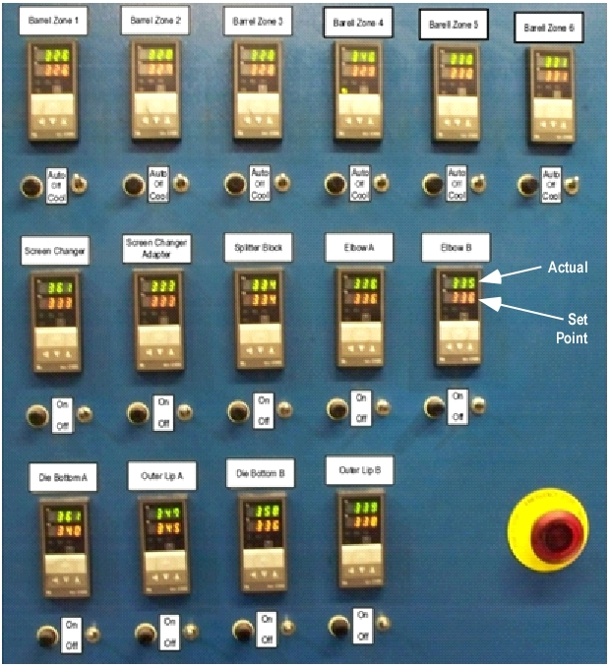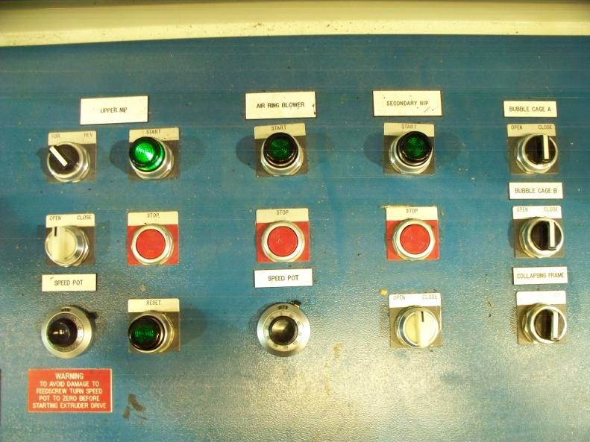

Figure 3 – Main Drives Displays Figure 4 – Bubble Air Control Valves
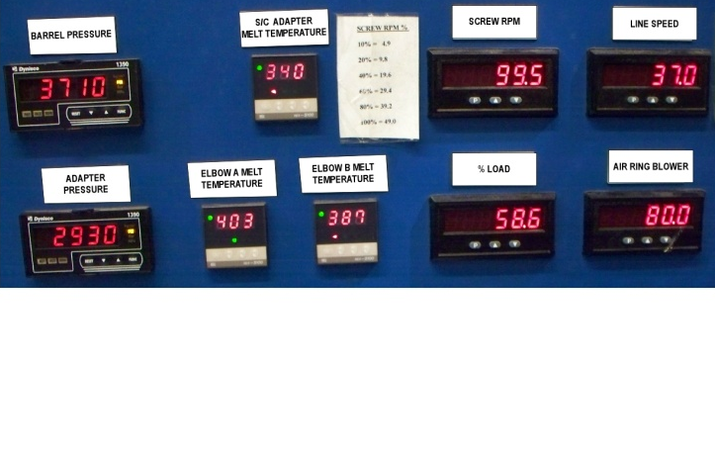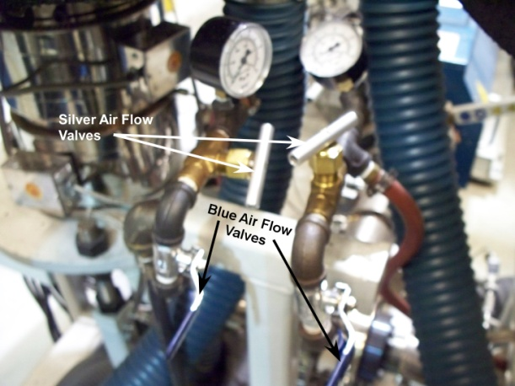
Figure 5 – Corona Treater Start Figure 6 – Treater Electrode Switch
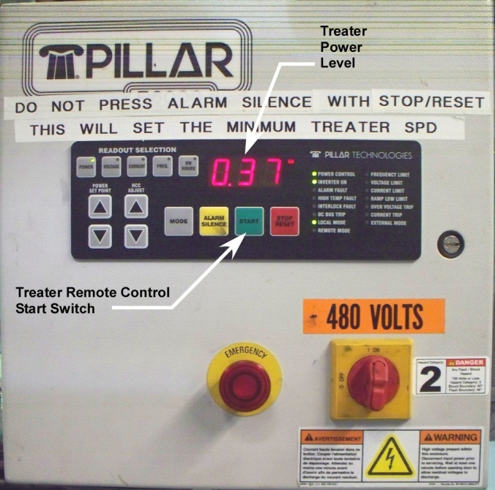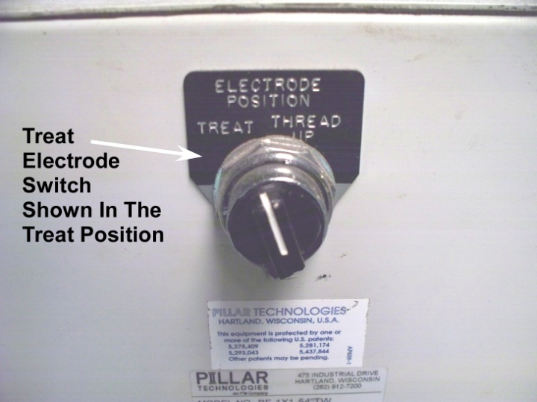
Figure 7 – Nip Pressure Regulator Figure 8 – Bag Machine Start Control
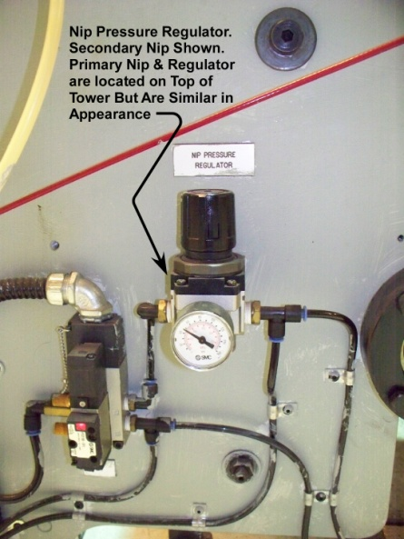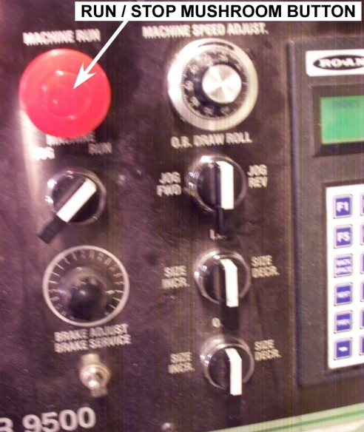

Figure 9 – Seal Power Controls Figure 10 – UV Control Panel
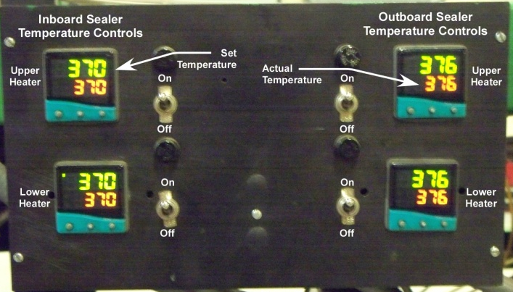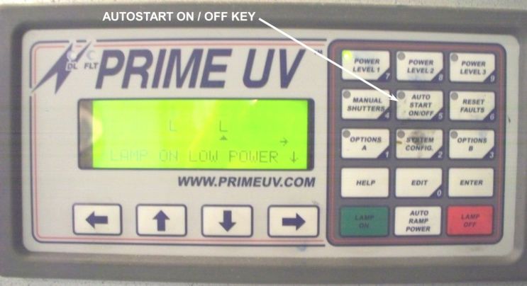
Figure 11 – Printing Deck
Squeeze Adjust Figure 12 – Photo Eye Adjust
