SIMAC “RED RING” HOUSING LESS

TYPE: HORIZONTAL AND VERTICAL STANDS

THE EXISTING MATERIALS OFFERED ARE COMPLETELY REVAMPED

The Available parts of a roughing section that can use billets up to 160 mm X 160 mm size is composed of:

N.1 HORIZONTAL VERSION

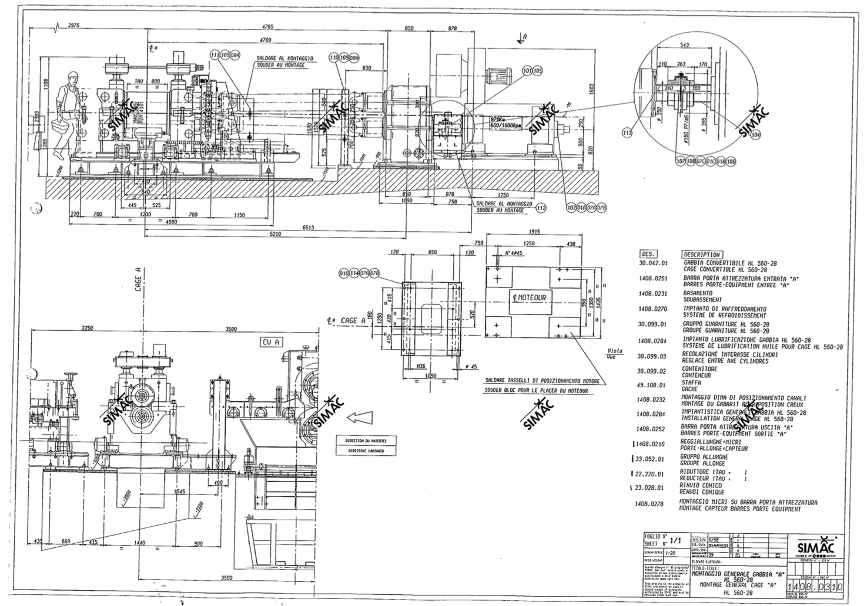

Cylinder stands:

- Cylinder diameter 600 mm – barrel diam. 800 mm – neck diam. 280 mm
- Cylinder grooved for billet 120-130-140-150-160 mm
- Housing Cast Steel complete with Hydraulic fixing bracket
- Lubrication system for Bearing
- Set of entry and exit guide
- Cooled Water pipe system for cylinder

Gear box – pinion stand units (GPR):
- Distance axe to axe 530 mm. properly ratio
- Body in steel welded and gear teeth high resistance hardened cemented,
- Complete with gear couplings in entry and coupling box in exit.
- Service factor 2

Cardanic spindles

Motor: DC MOTOR ‘ Electro Mecanique / Brown Boveri ’

- Power 445 Kw. 750 Volt complete with electrical panels and accessories.

N.1 CONVERTIBLE TYPE H/V

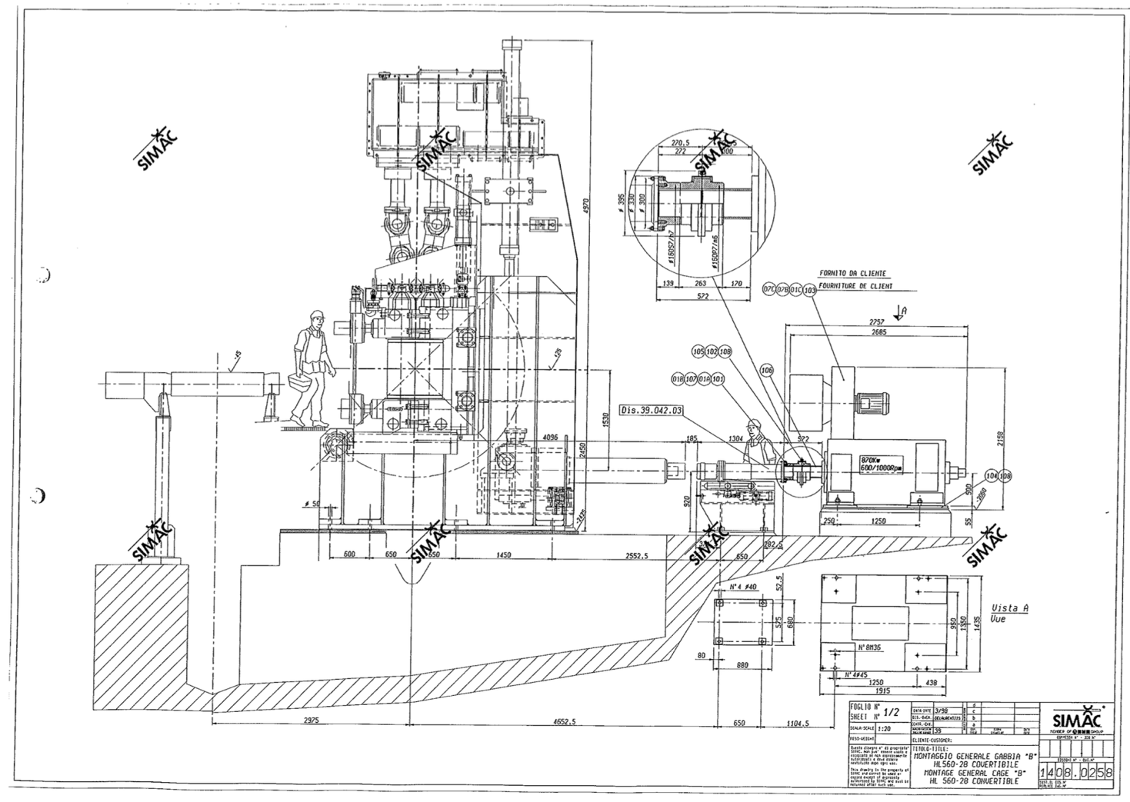

Cylinder stands:

- Cylinder diameter 600 mm – barrel diam. 800 mm – neck diam. 280 mm
- Cylinder grooved for billet 120-130-140-150-160 mm
- Housing Cast Steel complete with Hydraulic fixing bracket
- Set of entry and exit guide
- Lubrication system for Bearing
- Cooled Water pipe system for cylinder

Gear box – pinion stand units (GPR):
- Distance axe to axe 530 mm. properly ratio
- Body in steel welded and gear teeth high resistance hardened cemented,
- Complete with gear couplings in entry and coupling box in exit.
- Service factor 2

Cardanic spindles
N. 3 HORIZONTAL/VERTICAL VERSION

Cylinder stands:

- N.5 Cylinder diameter 600 mm – barrel diam. 800 mm – neck diam. 280 mm
- Cylinder grooved for billet 160 - 170
- Housing Cast Steel complete with Hydraulic fixing bracket
- Set of entry and exit guide
- Lubrication system for Bearing
- Cooled Water pipe system for cylinder

Cardanic spindles

Lubrication unit

Roll change robot for mill stands

The following documentation will be included in the supply:

- Hydraulic diagrams with list of components
- Electric circuits with components list
- Functional works
- Bearing list
- Spare parts list
- Motor list
- Sensor list

ENGINEERING

- Includes Lay-out drawings for machine positioning
- Load foundation drawings on them
- Machine assemblies

TERMS & CONDITIONS

DELIVERY TIME
6 months

DELIVERY TERMS
Ex work

PACKAGING
Included in sea containers od 20 or 40 feet

TERMS OF PAYMENT
50 % Advance Payment
50% Against shipping documents

The following offer regards what is available at the moment; anyway is possible to change or modify some part for being suitable to the customer’s needs.

