Power Generation at the Lyons Ferry site.
Power at Lyons Ferry is generated using a natural gas fired boiler powering a steam turbine generator (STG), and a Cummins natural gas generator (NGE). Power is produced at 13,800V and 60hz, up to 6.4mW when run in parallel. Up to 5MW comes from the STG and up to 1.4MW from the NGE. The parasitic load is approximately 600KW, bringing actual normal output to ~5.8MW.
The STG is supported by a water-cooled condenser to recycle used steam back into feed water and a Reverse Osmosis system for raw water makeup, along with a Marley 4 cell Cooling Tower. The NGE when paralleled with the STG is normally baseload controlled at 1000KW, while the STG is frequency controlled to handle all additional load.
Both systems do have minimum loads, the NGE needs to operate at a minimum of 70% or 980KW. The STGs minimum is approximately 1.6MW or 18KPPH steam flow from the boiler. During startup and operation of these systems a 1000KW load bank is used to control load. The NGE is required to bring the boiler online but can be shutdown once the STG is online or run in parallel.

Equipment-
Boiler- Victory Energy Voyager series superheated boiler with economizer. Manufactured in 2018, the boiler operates at 800PSI with a maximum output of 90KPPH
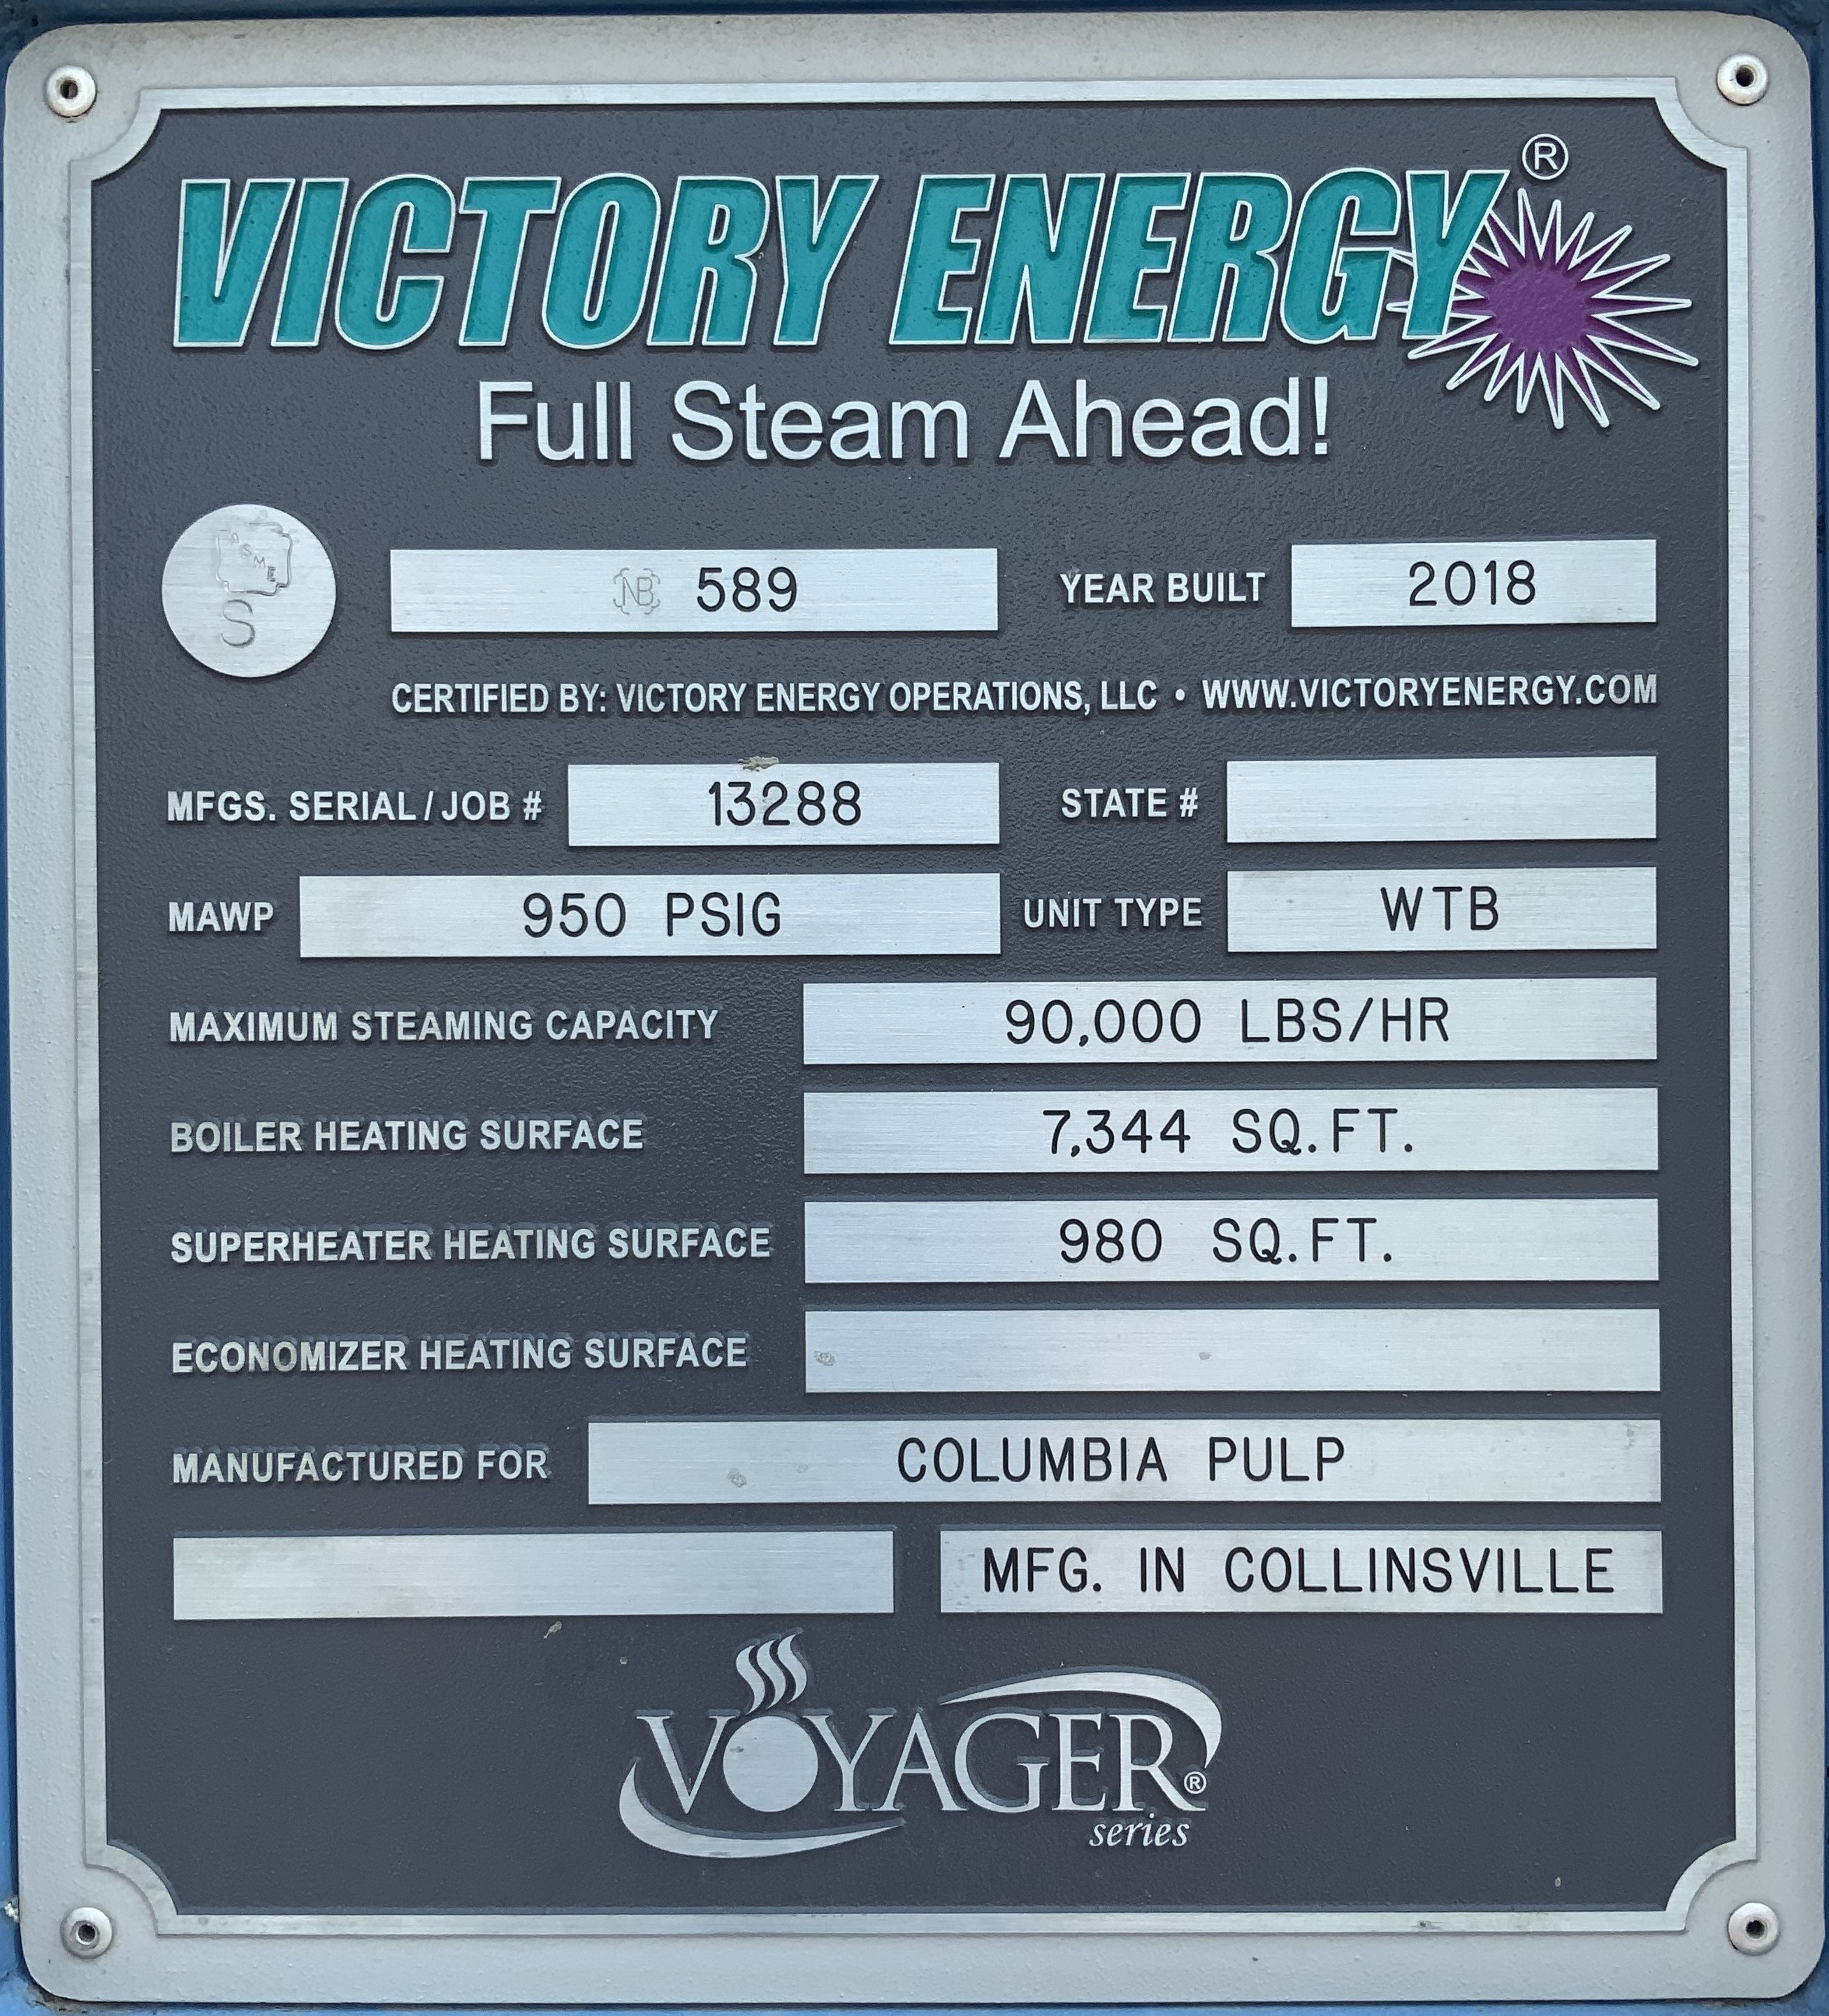
Turbine- Howden KK&K Twin CA56. Manufactured in 2018, the turbine operates at 1800RPM and allows for extraction steam
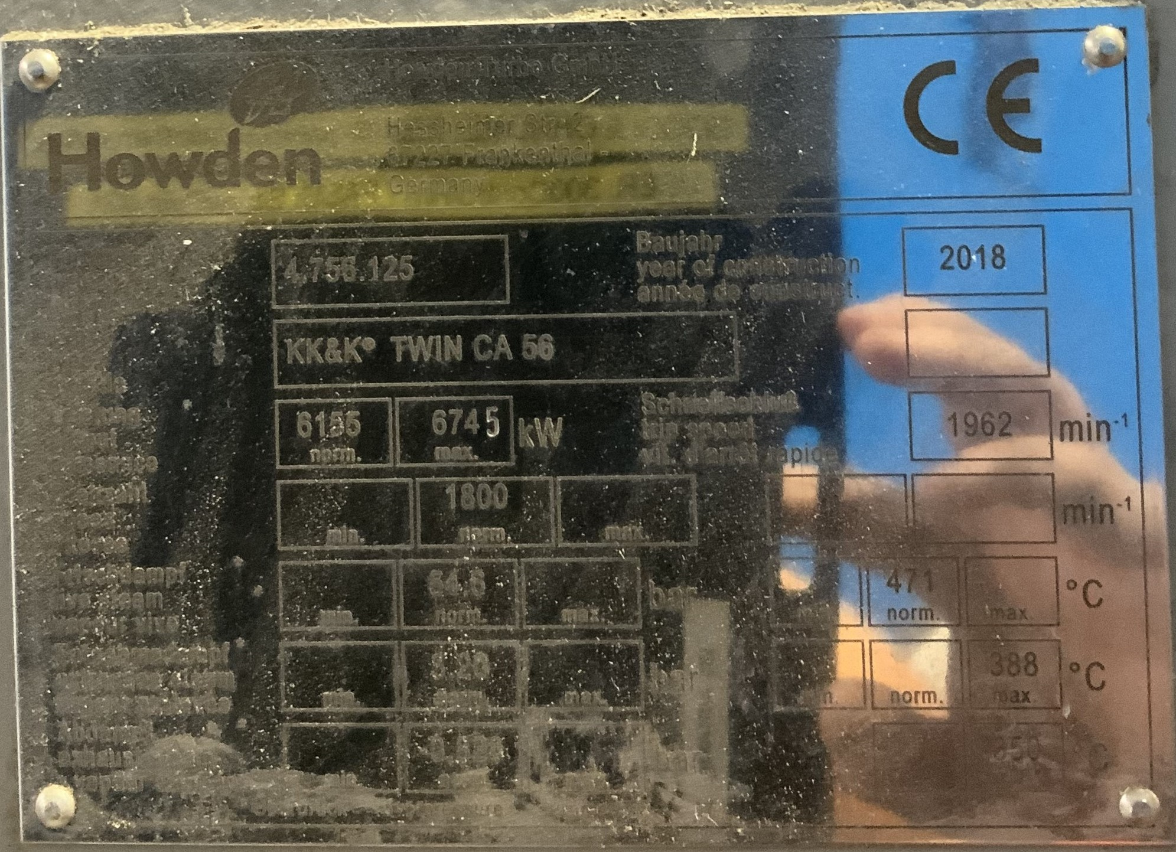
Generator- ToyoDenki Power Systems TC150. Manufactured on 2018. The generator operates at 1800RPM with a normal output of up to 5050KW.
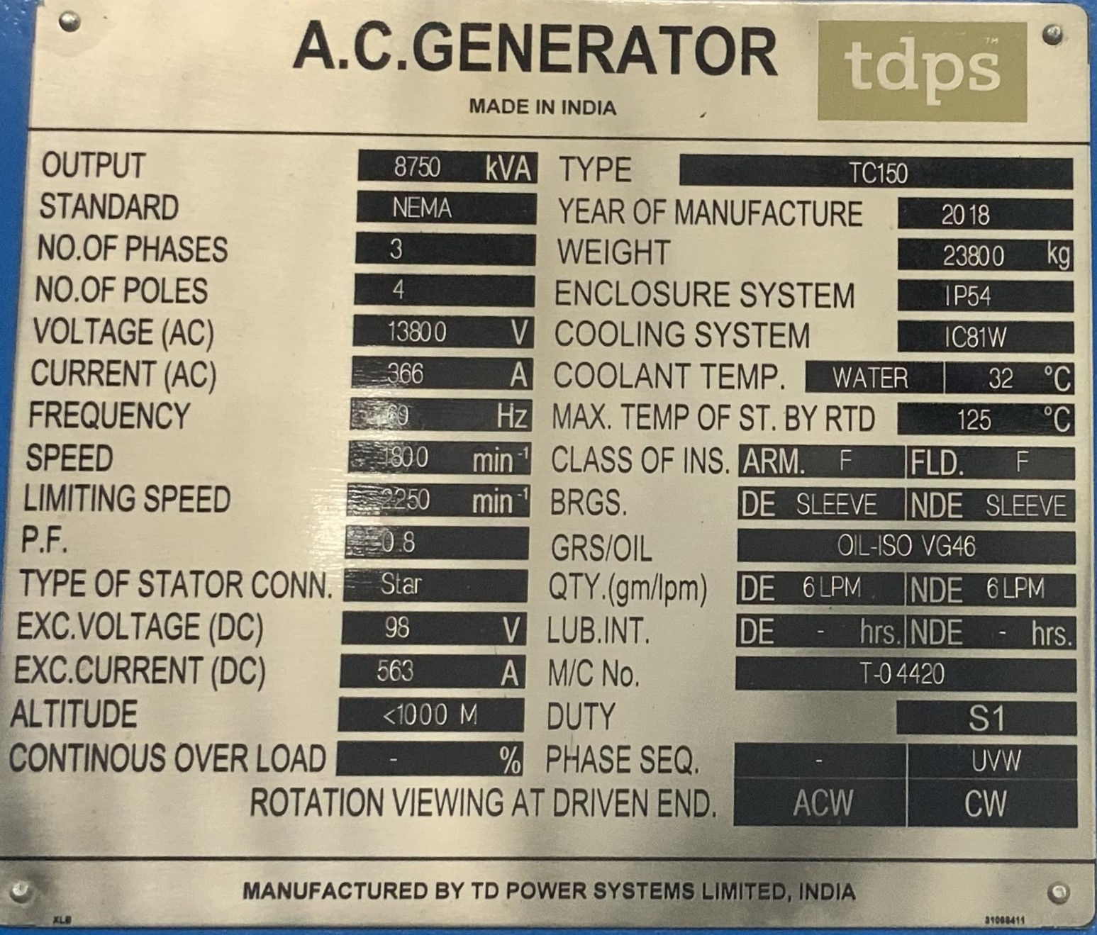

Natural Gas Engine Generator- Cummins QSK60G. Manufactured in 2018. Skid mounted (but not portable) engine/generator combination producing 13,800v up to 1400KW.
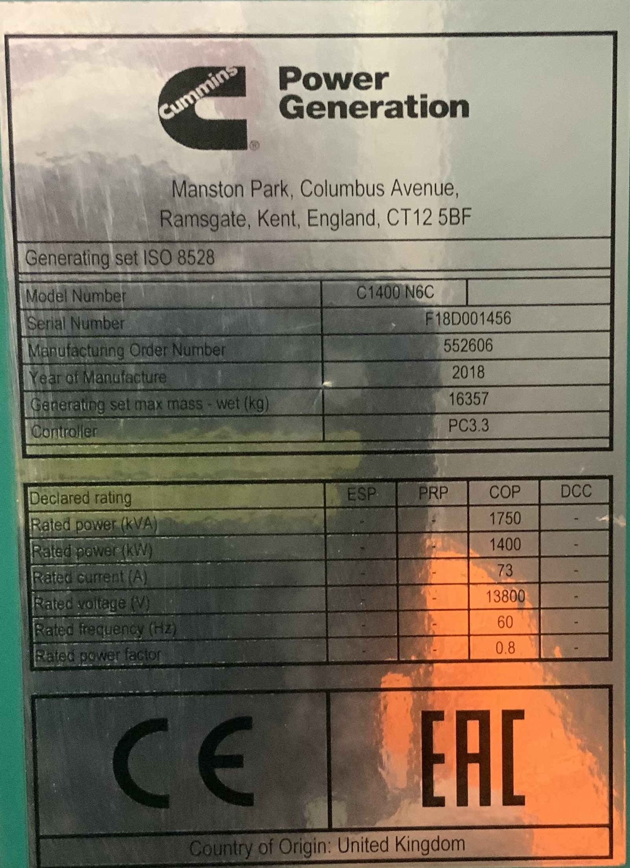

Ancillary systems- RO skid, Cooling Tower, Boiler Chemical addition, Cooling Tower chemical addition, Condenser, feedwater system, and Extraction (exhaust) Steam

