GIANT Model GDB-4836-DP Dry Blast Cabinet, 10-14 gauge steel fabricated heavy duty laser cut and hand welded construction, as specified and described below.

SPECIFICATIONS:
Product Name: | GSB-4836 Dry Blast Cabinet
Machine Type: | Direct Pressure Dry Blast Cabinet
Compressed Air Usage: | 65 CFM with a #5 blast nozzle
Door Openings: | 40” by 36” Side Doors with Adjustable Latches
Overall Width: | 48 inches
Overall Depth: | 36 inches
Overall Height: | 75 inches
Working Area Width: | 48 inches
Working Area Depth: | 36 inches
Working Area Height: | 36 inches
Construction: | 10-14 Gauge Steel Laser Cut & Hand Welded
Voltage | 120/1 PH
Paint | Powder Coated Hammer Tone Finish
Most Used Abrasive Type: | Glass Beads, Aluminum Oxide, & Baking Soda

Shipping Weight.................................................................................................400 lbs.

PRICE as described above…………………………$15,900.00

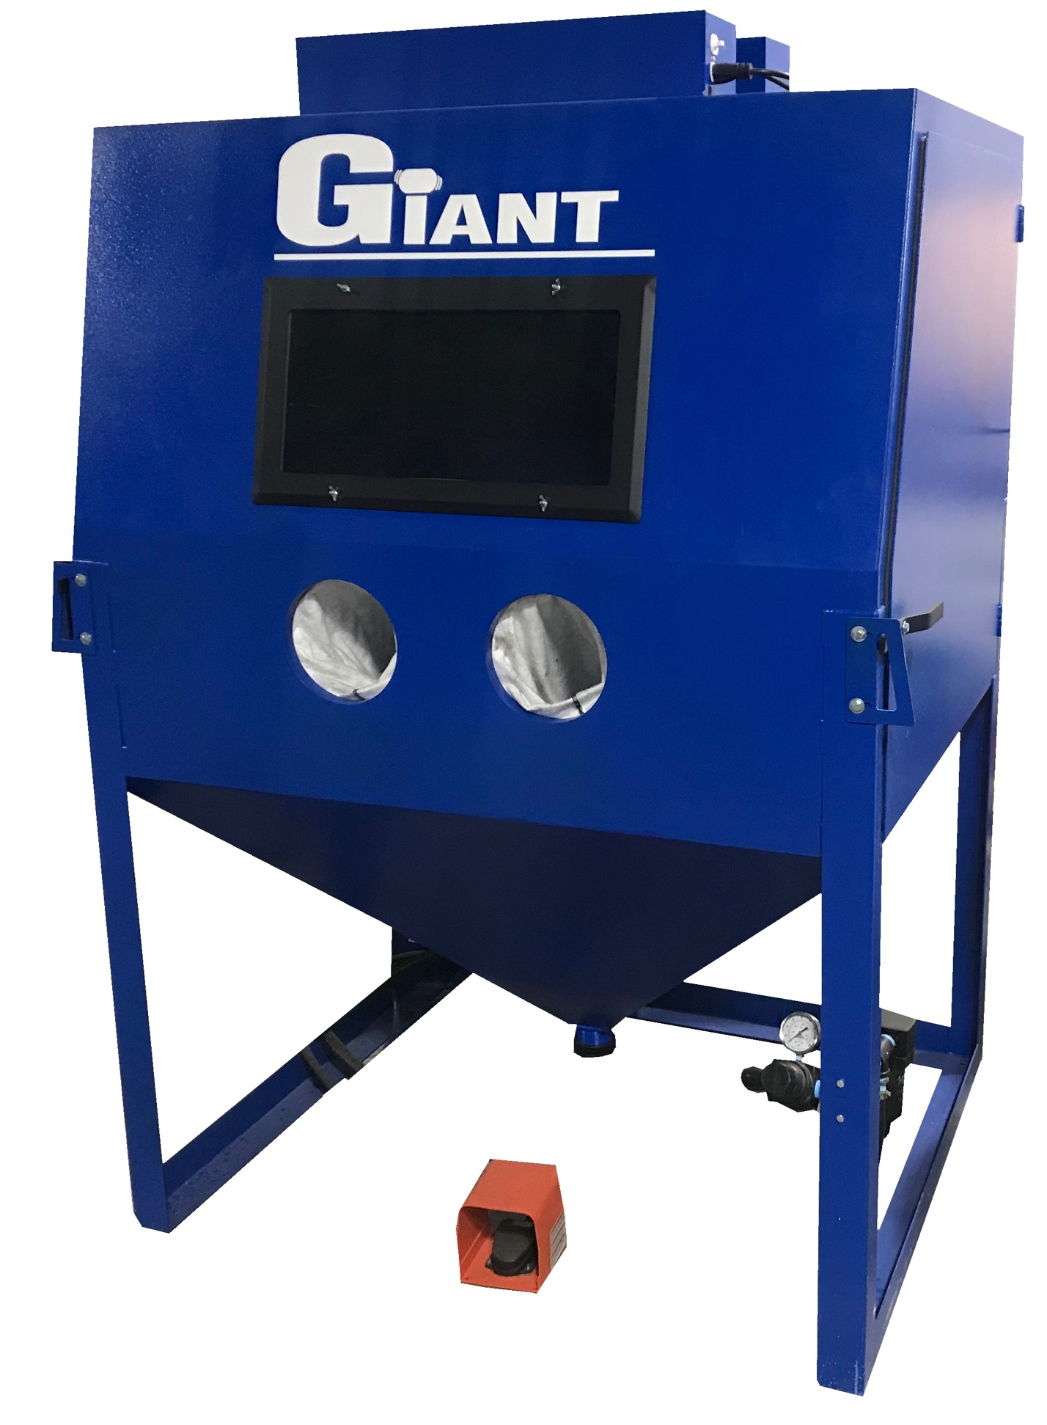

STANDARD FEATURES:

Direct Pressure Blast System
a complete Direct Pressure Blast System which incorporates a 1.5 cube Blast Pot with a high quality Micro Metering Valve, 900 CFM Reclaim and 900 Cartridge Style/Timed Reverse Pulse Dust Collector into the one unit. The result is a very high powered, state of the art Direct Pressure Blast System. The 2 HP/900 CFM dust collector combined with our 900 CFM reclaim insures clean media at all times for optimal performance.

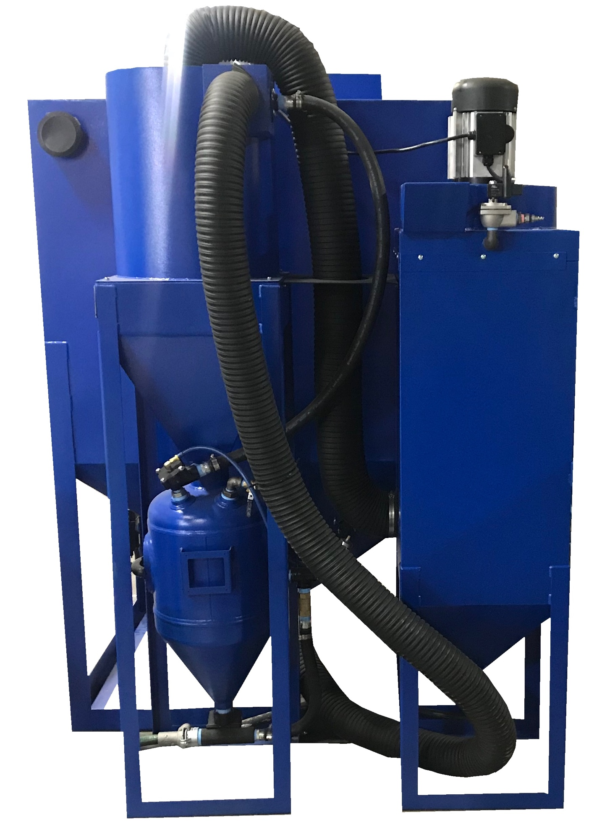
900 CFM Cartridge Style Dust Collector
a very high quality 2 HP 900 CFM cartridge style dust collector. This heavy duty collector is built entirely from 12 gauge steel and is 100% hand welded. This means it has no seams that can leak dust. The pleated cartridge filter is loaded from the top of the cabinet which is a very unique design that ensures a tight seal. Cleaning the filter is accomplished automatically by a reverse pulse system that has a digital timer which pulses the system at a preset interval. This ensures that the filter is functioning at its highest level at all times. The sump is then emptied from the bottom of the collector.

Foot Pedal Operation
Dual Access Side Doors
Ergonomic Style Blast Gun
20 Watt LED Lamp
Air Regulator

OPTIONS:

Rubber Lining Kit………………………………………………………$ 1,100.00

26” Turn Table………………………………………………………….$ 1,100.00

Glass Beads (50 lb. Pail)…………………………………………….………$ 75.00

Aluminum Oxide (50 lb. Pail)………………………………………………$ 95.00

Baking Soda (50 lb. Pail)…………………………………………………….$ 50.00

MADE IN U.S.A.

Prices are firm for 45 days from date of Quotation.

DELIVERY: 2 - 6 Weeks

F.O.B. : Addison, IL

TERMS : 50% With purchase order.
50% Prior to shipment
WE ACCEPT ALL MAJOR CREDIT CARDS 

PURCHASE ORDERS ARE TO BE ISSUED DIRECTLY TO GIANT FINISHING, INC.

Very truly yours,

Mark Oryszczak

