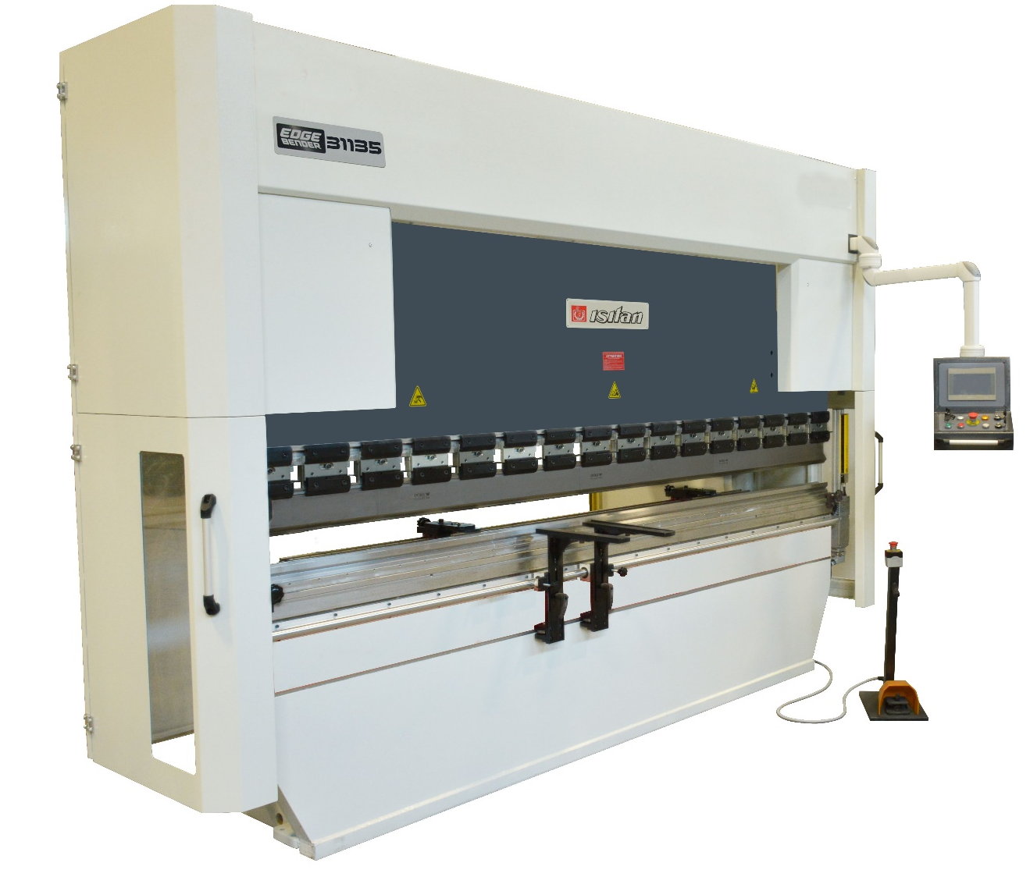

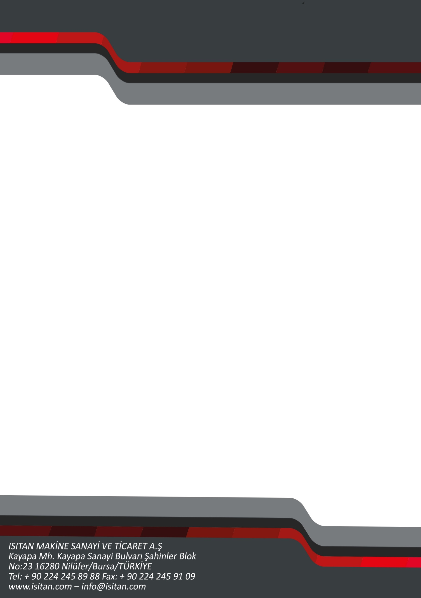
V I D E O
2 (X+Y) AXIS NC CONTROLLED
HYDRAULIC PRESSBRAKES
EB 31135-NC

SAMPLE MACHINE PHOTO



STANDARD EQUIPMENT
- Bending system with double Double Cylinder on the upper table.
- Static and dynamic rigidity provided, strong construction with steel frame and upper table material.
- Upper table movement supported by easily adjustable fiber slide bearings.
- Durable balancing spindle and eccentric spindleballs that aid parallelism.
- Stroke controlled angle adjustment mechanism with mechanical-stop system and motor control.
- High stroke and front opening values ​​that facilitate the use of different bending molds.
- Easy tonnage adjustment with pressure switch and stop at lower stroke point via NC control.
- Hydraulic safety system against excessive pressure rise.
- Double speed working system: Free Fall, Bending, Return Back
- Multi-function foot pedal with emergency stop connected to the NC Controller, normal pressing, stopping at the desired position, automatic table return functions can ball be controlled easily.
- Compact, low maintenance HOERBIGER hydraulic system unit located at the back-top of the machine.
- Service solution with remote connection with European origin SIEMENS electrical equipment.
- Thanks to LEUZE brand for securty system, the front barrier bending in different forms with learning mode.
- Easily floating arm control panel
- Sensitive programmable retreat function on Backgauge to avoid collision Thanks to LEUZE brand for security system, the front barrier bending in different forms with learning mode.
- NC control unit, which can write standard 500 programs / 200 lines, adjust the angle and backup of the program by USB.
- Standard upper tools and Bottom Die
- Motorized X and motorized R-axis (OPTION) backgauge with motorized X and motorized R axes that can move at high speed and programmed via NC control supported with line arguide ways: 600 mm backgauge distance and 0.2 mm operating precision, the gauge height is precisely adjusted.
- Y AXIS Angle Setting by Motor and NC Controller
- Manual crowning system and Manual adjustable wedges for aligning the top tools.
- Quick-release PROMECAM top tool clamping system for partial and quick removing.
- Move able control panel.
- Front support arms that can be easily moved with line arslide and bearing systems.
- Tigh tening and fixing bolts toalign the bottom die.
- Safety enabled foot pedal with emergency stop connected to the NC controller enables safe work environment and compatible with CE
- Thanks to Selection / Drawing Toolings Feature on controller and bending power control, the results are in correct parameters.

OPTIONAL EQUIPMENT
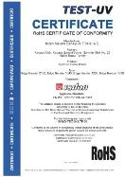
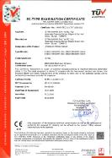
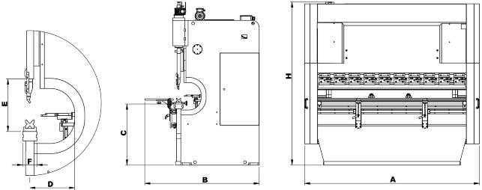
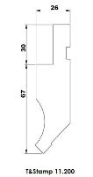
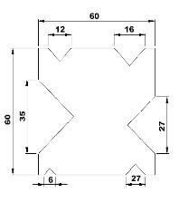
- Special bending dies.
- Special pedal system with two hand and foot control.
- Special safety systems. (DSP, FIESSLER)
- Additional lenght in backgauge
- Extra backgauge fingers
- Extra Front Support arms
- Motorized R-axis
- Servo Motorized R-axis for precision movement
- Servo Motorized X-axis for precision movement
- Manual or Motorized Cambering

TECHNICAL SPECIFICATIONS
CAPACITY EB 31135 NC
Bending Power | ton | 135
Bending Capacity | mm | 6
Working Length | mm | 3150
Distance Between Frames | mm | 2600
Stroke | mm | 250
Throat Depth | mm | 415
Daylight | mm | 500
Table Width (F) | mm | 100
Table Height (C) | mm | 845
Motor Power | kw | 15
X Axis Motor | kw | 0,75
Y Axis Motor | kw | 0,55
R Axis Motor | kw | 0,37
Backgauge | mm | 600
Tank Capacity | lt | 150
Bending Capacity 42 kgf/mm | mm | 6
Bending Capacity 72 kgf/mm | mm | 4
Y Free Fall Speed | mm/s | 140
Y Working Speed | mm/s | 10
Y Return Speed | mm/s | 120
Front Support Arms | pc | 2
Back Gauge Fingers | pc | 2
LxWxH | mm | 3600x1800x2500
Weight | kg | 7300

STANDARD SPECIFICATIONS
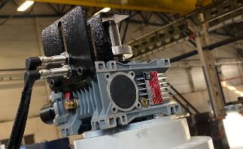
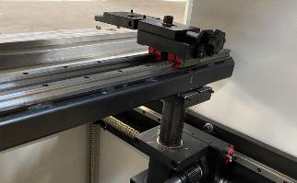

Gear Box Driven Angle Adjustment System
Motorized Backguage with Ballscrew

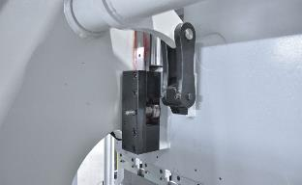
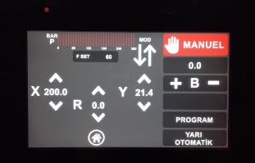

Torsion Bar Eanbling Sensitive Bending
User Friendly Interface on NC Control
2 Axis Multilingual NC Controller, 500 Program Memory + USB Expandable

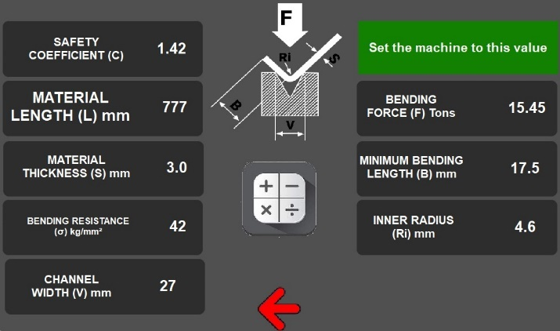
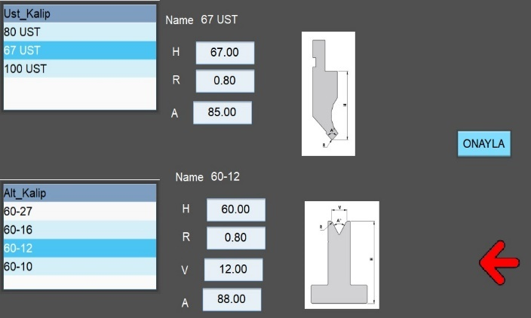

Selection and Drawing Tooling Feature on Controller
Sensitively Bending Feature

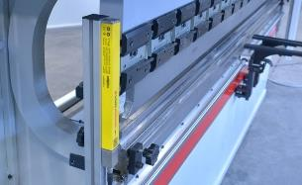
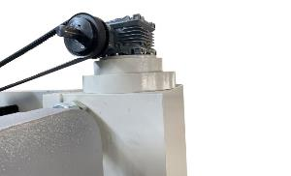

NC + MOTOR and Reducer Controlled Angle Adjustment
STANDARD : LEUZE Lıghtguard Wıth Work Area Learnıng Feature

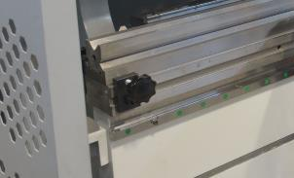
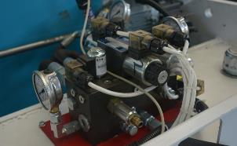


Easy Adjustment and Fixing on Lower Die Bed
or REXROTH HYDRAULIC
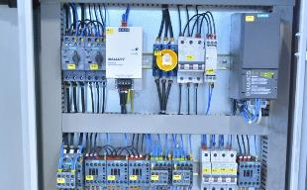
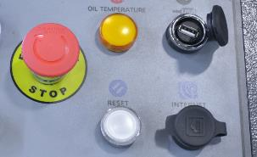

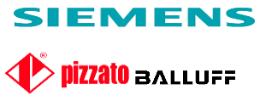
Remote Assistance and Maintainance With Network
ELECTRIC EQUIPMENTS

OPTIONAL SPECIFICATIONS
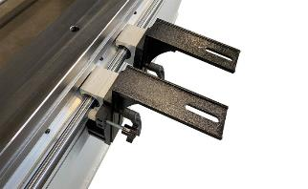
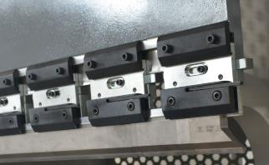
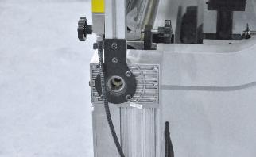
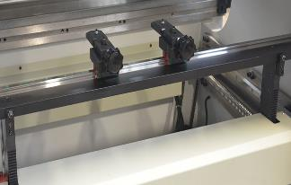

Seperate Height Set on Front Support
Promecam Blade Installed

Motorized Backgauge
Optional Motorized or Manual Lower Blade Cambering

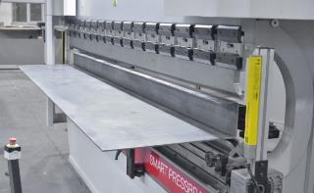
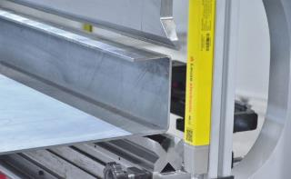

Presicion Bending Results
Safety Lightguard Compliyng With CE
SALES CONDITIONS
COMPANY NAME |  | :
CONTACT PERSON |  | :
ADDRESS |  | :
PHONE |  | :
MAIL |  | :

- NET MACHINE PRICE : …….. Euro – NET/EXW

Options;
Finger Protection DSP Laser : (-)
Finger Protection Fiessler Laser : (-)
Motorized Backgauge (R Axis) : (-)
Servo Motorized Backgauge (R Axis) : (-)
Servo Motorized Backgauge (X Axis) : (-)
Double Button and Pedestal Controller : (-)
Extended Backgauge (1000 mm) : (-)
Additional Backgauge Finger (1pcs) : (-)
Additional Front Support Arm (1pcs) : (-)
Manual Crowning for Bottom Die : (-)
Motorized Crowning for Bottom Die : (-)
GRAND TOTAL : ……… Euro – NET/EXW

- DELIVERY TIME : ….. days after your official order
- PAYMENT TERMS :
- DELIVERY TERMS :
- OFFER VALIDITY :

- GUARANTEE : During 12 months from delivery date, the machine is covered by integral guarantee. ISITAN MACHINE supplies a complete assistance including the replacement of defective parts and and/or workmanship under normal use and service. Technician stay & Traveling expenses and transport cost for warranty parts are on customer's charge.

- HS CODE : 8462.29.00.00.00
- PACKING SIZES / WEIGHT :LxWxH = 3600x1800x2500mm - WEIGHT = 7300 kg / 1pc.

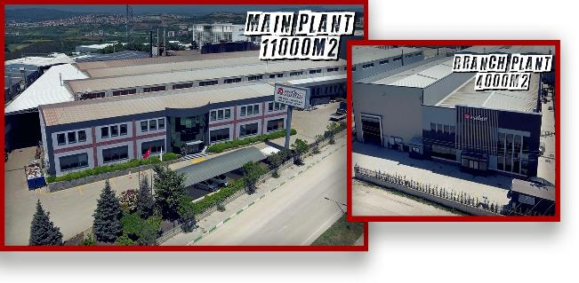

ISITAN MAKINE established on 1959 in a small workshop in BURSA and produced over thousands of Trimming and Plate Bending-Rolling Machines to thinsmiths and stove workshops until 1970 to domestic market, even today; most of those Machines are still used in the production of many companies all over Turkey.
From 1970 till 1980 ISITAN MAKINE continued its production with the addition of bigger size Pyramidal Plate Bending Machines besides of new design Trimming Machines, Circular Cutting Shears and Flanging Machines and on 1996 with the new menagement the company has started its first export sale.
Since 1959 until today ISITAN MAKINE continued its grove with customer satisfaction and after sale support, today Isitan carries its production in 15.000m2 closed production area with 120 employees. Ability of producing new models is the key of ISITAN MAKINE's on going success and today we produce 3 and 4 Roll Plate Bending Machines, Trimming-Bordering Machines, Pressbrakes, Circular Cutting and Flanging Machines, Pipe Nothers, Pipe End-Forming Machines, Wet Type Circular Cut Off Saw Machines, CNC and NC Pipe Bending Machines with mandrel, Non-mandrel Rotary Draw Pipe Benders.







Since 1959
Scan for Social Media.
Scan for PDF Catalogue.
Scan for Location

