Product Overview

High-shear emulsifiers are essential mixing and homogenization machinery widely used in the fields of food and beverage, chemicals, biochemistry, petrochemicals, pigments, dyes, coatings, and pharmaceuticals. They are characterized by their simple overall structure, compact size, light weight, ease of operation, low noise, and smooth operation.

A key feature is that the production process does not require any grinding media. Instead, these machines integrate multiple functions into one unit, including high-speed shearing, dispersing, emulsifying, homogenizing, mixing, crushing, and conveying.
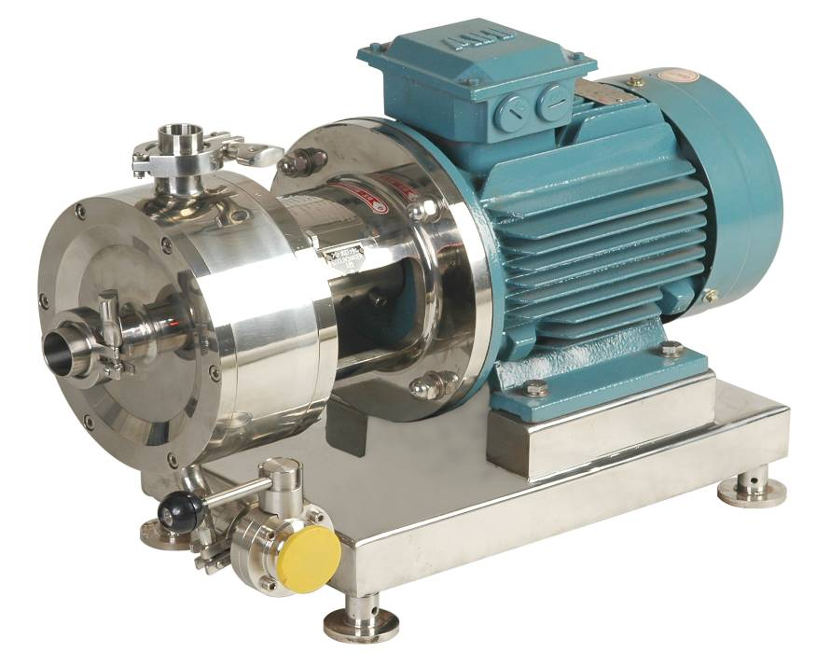

Operating Instructions for SRH In-Line Emulsifier

1.Feeding Method: Materials can typically be fed into the SRH in-line unit via gravity from a elevated supply. Feeding must be continuous, and the material must maintain good fluidity. For materials with poor fluidity (viscosity ≥ 4,000 cP), a feed pump must be used at the inlet of the SRH unit, with a pumping pressure of 0.3 MPa. The pump selected (e.g., a colloidal pump/rotor pump) must have a flow rate matching the flow range of the chosen in-line emulsifier. The flow rate should be greater than the minimum value and less than the maximum value specified for the emulsifier.

2.Foreign Object Prohibition: Strictly prohibit metal chips or other hard, difficult-to-break foreign objects from entering the working chamber, as they can cause catastrophic damage to the stator, rotor, and the equipment.

3.Abnormal Operation & Shutdown: If any abnormal noise or other malfunction occurs during operation, immediately stop the machine. Investigate and rectify the fault before restarting. After shutdown, thoroughly clean the working chamber, stator, and rotor.

4.Jacketed Chamber (Temperature Control): The process working chamber of the SRH in-line unit can be optionally fitted with a insulation/tempering jacket for heating or cooling the material. Before starting, circulate the coolant or thermal oil. The working pressure in the tempering jacket must be ≤ 0.2 MPa. For materials with specific temperature requirements (e.g., asphalt), ensure the material is heated or cooled to the normal operating temperature before barring (manually rotating), and starting the machine.

5.Explosive Environments: When the equipment is used in flammable or explosive environments, a motor with the corresponding explosion-proof rating must be selected and used.

6.Post-Operation Cleaning: After production, the equipment must be thoroughly cleaned. This maintains the efficiency of the stator and rotor and protects the mechanical seal. If necessary, design and install a external Cleaning-in-Place (CIP) circulation system nearby.

7.Filtration & Material Consistency: Depending on the medium being processed, the inlet and outlet filters must be cleaned regularly to prevent reduced feed flow and loss of production efficiency. Material entering the working chamber must be fluid; dry powders or agglomerated materials are not allowed, as they can cause the machine to jam and result in damage.

8.Component Inspection: Regularly inspect the stator and rotor. If excessive wear is found, replace the corresponding parts promptly to ensure proper dispersion and emulsification performance.

9.Shaft Seal Leakage: If liquid leakage is observed at the shaft during operation of the SRH in-line unit, stop the machine and adjust the mechanical seal pressure. (Refer to the separate 'Mechanical Seal Instructions' for detailed guidance).

10.Safety Procedures: Establish corresponding safe operating procedures before using this equipment to ensure the safety of personnel and the equipment. The electrical control system provided by the user must include safety protection features, and have a reliable grounding connection for the motor and electrical components.

Equipment Disassembly and Installation
(I) Disassembly
- Preparation: This disassembly guide uses the SRH in-line unit as the primary example. (The process for the main assembly of the WRL batch-type unit is similar and thus omitted.) Referring to the SRH in-line product diagram, first disconnect all external connections to the equipment to ensure the work area is clear and unobstructed for the disassembly tasks.
- Stator Removal: Loosen the connecting bolts on the stator (1). Once loose, carefully slide the stator out horizontally. Crucial Note: Exercise extreme caution to prevent the stator teeth from contacting the rotor during this process, as such contact can damage both components.
- Rotor Removal: Insert a Ø10 round steel bar into the designated service hole on the main shaft (6). Using a wrench, loosen the cap nut on the main shaft. Subsequently, remove the rotor (2) and the adjustment sleeve.
- Housing Removal: Unbolt and remove the connecting bolts fastening the support bracket (4) to the housing (working chamber) (3). Then, carefully remove the housing (3).
- Mechanical Seal: For the disassembly and assembly procedures of the mechanical seal (5), please refer to the separate attached document: Mechanical Seal Instructions.
- Main Shaft Removal: Loosen the set screw on the motor shaft. The main shaft can then be removed, completing the equipment disassembly.
(II) Installation
The installation procedure is essentially the reverse sequence of the disassembly steps described above. Apply the principles demonstrated in the disassembly guide to correctly reassemble the unit.

Mechanical Seal Maintenance Instructions
I. Operating Conditions
- Medium: Paste, Liquid
- Pressure: ≤ 0.3 MPa
- Speed: 2900 rpm
- Temperature: ≤ 120 °C
II. Flushing Fluid Conditions
- Medium: Water
- Temperature: Ambient Temperature
- Pressure: 0.2 MPa
III. Main Technical Parameters
- Model: SRH-100
- Flow Rate: 2 T/h
- Motor Power: 2.2 kW
- Speed: 0 - 2900 rpm
- Outlet Pressure: ≤ 0.2 MPa

Installation and Commissioning
- Inspect the inlet and outlet of the high-shear dispersing emulsifier to ensure the seals are intact and that no foreign objects, such as debris or metal chips, which could damage the equipment, have entered the unit.
- Check the electric motor and the complete machine for any damage that may have occurred during transport or storage. When connecting the power switch, ensure a safety electrical contact device is installed.
- Before connecting the equipment's inlet and outlet to the process pipelines, thoroughly clean the pipelines. Ensure they are free of weld spatter, metal chips, glass fragments, quartz sand, or any other hard substances that could damage the equipment before making the connections.
- For the SRH in-line unit, select an installation location closest to the container, such as its bottom. The piping must be as simple and direct as possible, minimizing the use of elbows and fittings to reduce flow resistance.
- The WRL batch-type unit should ideally be installed vertically and level relative to the container. If installed at an angle, ensure all seals are effective, providing protection against moisture, dust, dampness, and meeting explosion-proof requirements if applicable.
- Prior to starting the machine, manually rotate the main shaft (barring). The rotation should feel uniformly smooth, flexible, and free from any friction or abnormal noises.
- When installing the SRH in-line unit into the pipeline, use quick-release clamp fittings for the inlet and outlet connections.
- After completing all the above steps, activate the power supply. Repeatedly switch the power on and off briefly to check that the motor rotation direction corresponds with the direction indicator on the main shaft. Reverse rotation and dry running (operating without material) are strictly prohibited. If the machine operates normally, it is ready for production.

Product Structure Diagram (SRH Series)

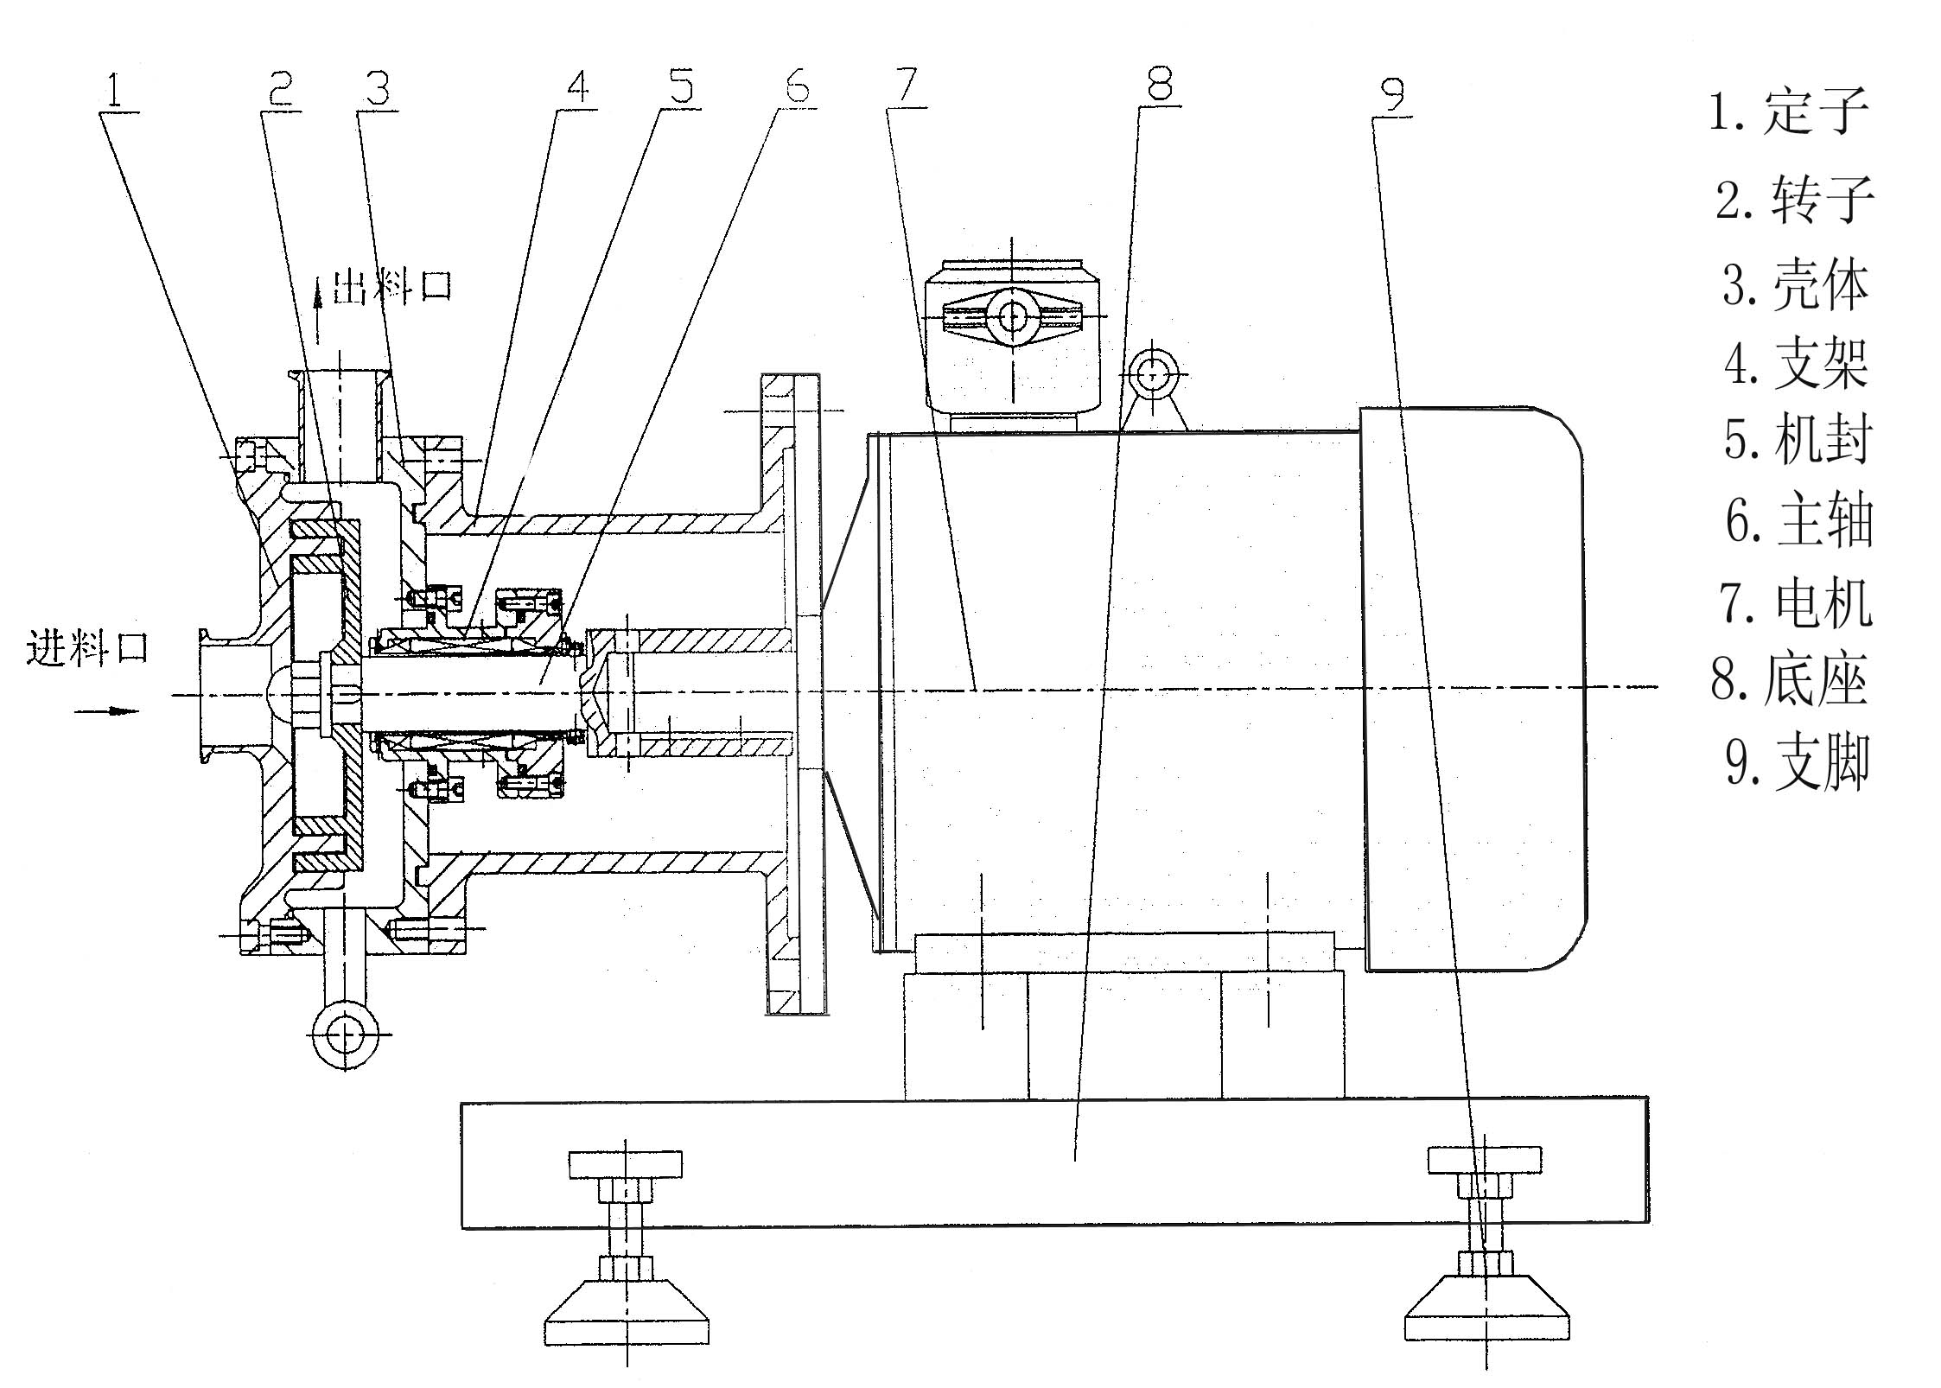

Operation and Maintenance
- For the SRH in-line unit, connect the cooling water for the mechanical seal before starting the machine. When shutting down, turn off the machine first before disconnecting the cooling water. Standard tap water is sufficient for cooling, with a water pressure ≤ 0.2 MPa. The machine must only be started after material has entered the working chamber. Ensure it does not run without material (dry running), as this can cause the mechanical seal to overheat and burn out, significantly reducing its service life. The cooling water inlet and outlet connectors are fitted for Ø8mm hose.
- After confirming the mechanical seal cooling water is connected and flowing, start the motor. It is imperative to double-check that the motor rotation direction matches the direction indicator on the main shaft before operation. Reverse rotation is strictly prohibited!
- During operation, liquid material must be fed continuously or maintained at a sufficient level in the supply container. Avoid running the machine without material ("dry running"), as this can generate excessive heat or cause material to crystallize and solidify within the working chamber, potentially damaging the equipment. Dry running is strictly prohibited!

Troubleshooting Guide

Fault | Cause | Troubleshooting
No discharge or insufficient discharge from SRH pipeline-type equipment | 1. Valves are not open or the inlet/outlet pipelines are blocked. | 1. Open the valves and clean the blocked pipelines.
 | 2. The pipeline system is complex, resulting in excessive resistance. | 2. Simplify and shorten the pipeline design.
 | 3. The equipment is running in reverse. | 3. Adjust the power connection circuit of the motor.
 | 4. The material viscosity is too high. | 4. Install an additional transfer pump at the equipment inlet or dilute the material.
Equipment vibration with metal friction noise | 1. Impact from hard materials such as metal causes spindle eccentricity. | 1. Remove hard impurities and replace the spindle.
Equipment vibration with metal friction noise | 2. Impact from hard materials such as metal causes slight deformation of the stator and rotor. | 2. Remove hard impurities, repair or replace the stator and rotor.
Sudden equipment shutdown with immobile rotating disc | 1. Impact from hard material impurities such as metal shavings causes spindle eccentricity or stator/rotor deformation, leading to jamming. | 1. Remove hard impurities, repair or replace the stator and rotor.
Sudden equipment shutdown with immobile rotating disc | 2. Excessively high material viscosity, or overload tripping of the conveying flow at the inlet front end of the SRH pipeline-type equipment, or motor burnout. | 2. Adjust the material viscosity, select a feed pump with matching flow rate, or adjust the feed pump flow rate.
Leakage | 1. Damaged static seal ring. | 1. Replace the static seal ring.
Leakage | 2. Uneven force on the sealing surface. | 2. Adjust the force on the sealing surface.
Leakage | 3. Mechanical seal leakage. | 3. Replace mechanical seal components or dynamic/static ring O-rings.

SRH Series In-Line High-Shear Process Description
The SRH Series In-Line High-Shear Dispersion Emulsifier is a high-performance machine designed for the continuous production or recirculation processing of fine materials. Within its compact processing chamber, 1 to3 sets of multi-layered, precision-meshing stator-rotor pairs are installed. Driven by the motor, the rotor rotates at a high speed, generating a powerful axial suction force that draws the material into the chamber. The material undergoes intense dispersion, shearing, and emulsification within an extremely short period. This process significantly narrows the particle size distribution range, enabling the production of a refined and exceptionally stable end product.

Specifications and Applications of SRH Series In-Line High-Shear Dispersion Teeth

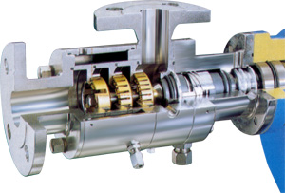

Coarse Teeth: Impact, Crushing, Shearing, Dissolving, Coarse Dispersion

Medium Teeth: Dispersion, Refining, Accelerated Dissolving, Emulsification

Fine Teeth: Ultra-Fine Dispersion, Enhanced Emulsification, Homogenization, Pulping

III. Technical Requirements for Mechanical Seal Installation

The shaft (or shaft sleeve) for seal installation must have a radial runout tolerance of < 0.04 mm, an outer diameter tolerance of h6, and a surface roughness (Ra) not exceeding 3.2 µm.

During operation of the equipment or other similar rotating machinery equipped with this seal, the rotor's axial movement (float) must not exceed 0.3 mm.

The locating face of the seal chamber that mates with the seal end cover must have a runout tolerance relative to the shaft (or shaft sleeve) surface of 0.04 mm. The surface roughness (Ra) of the area contacting the auxiliary sealing ring must not exceed 3.2 µm.

IV. Mechanical Seal Installation and Disassembly

A. Precautions Before Installation

Before installation, first inspect the shaft (or shaft sleeve) surface, the inner wall of the seal chamber, and the inner surface of the seal gland for burrs or grooves. If any burrs or grooves are found, they must be smoothed and polished. Clean these parts with gasoline and ensure they are kept clean, with no contaminants left on the surfaces.

Check all components of the mechanical seal for damage, paying particular attention to whether the sealing faces of the stationary and rotating rings have any nicks or scratches. If any damage is found, the parts must be repaired or replaced. Clean all components with gasoline, ensuring their surfaces—especially the friction faces—are free of dust, iron chips, and other impurities.

Do not clean the faces of the rotating or stationary rings with unclean materials. Use clean, soft materials such as lint-free cloth or tissue for wiping. During assembly, apply a layer of clean engine oil or turbine oil to the sealing faces of both the rotating and stationary rings, and to the contact surface between the rotating ring seal and the shaft (or shaft sleeve).

B. Mechanical Seal Installation

This mechanical seal is an internally-mounted type. The assembly configuration is shown in Figure 4.

Installation Steps:

First, install the mechanical seal onto the chamber as shown in the diagram and tighten the connection screws (8).

Tighten the set screw (1) on the seal shaft sleeve.

Loosen the screw (2) and then remove the positioning block (3).

Disassembly Steps:

The disassembly sequence is the reverse of the installation order:

Place the positioning block (3) onto the shaft sleeve, then tighten the screw (2).

Loosen the set screw (1) on the seal shaft sleeve.

Loosen the screws (8), then remove the mechanical seal from the chamber.

V. Mechanical Seal Operation
- Before starting the equipment, conduct a static pressure test on the mechanical seal to check for leakage. If leakage is observed, identify the cause and attempt to eliminate it. If unsuccessful, disassemble the seal for inspection and reinstall it. Repeat this process until the static pressure test shows no leakage (or only very slight leakage).
- Manually rotate (bar) the shaft in the same direction as the normal operating rotation. Check that the rotation feels smooth and effortless. If the shaft is difficult or impossible to turn by hand, inspect the installation for correctness.
- Crucially, before starting, ensure the seal chamber is completely filled with liquid and that any air has been purged from the chamber. First, turn on the cooling water, then start the equipment. During operation, ensure the mechanical seal does not run in a dry or rubbing state.
- When shutting down, first stop the equipment, then close the sealing/liquid inlet valve.

VI. Mechanical Seal Maintenance During Operation
During equipment operation, observe the following:
- After each operation run, immediately flush the seal chamber. Ordinary tap water can be used for flushing, with the pressure controlled below 0.05 MPa. Generally, a flow sufficient to ensure circulation is adequate. The purpose is to cool the seal and wash away any potential leaked materials, ensuring the mechanical seal is in optimal condition for subsequent use.
- Excessively high external flush pressure is detrimental to the operation and lifespan of the mechanical seal.
- If leakage is observed after startup and the amount is minor, allow a brief run-in period for it to stabilize to a normal level. If leakage does not decrease after 10 hours of continuous operation, stop the equipment for inspection.
- Monitor the seal frequently during operation. If the leakage rate exceeds the standard specification, stop the equipment for inspection.
- Pay attention to temperature changes. After the initial temperature rise stabilizes, the seal chamber area should not be too hot to touch.

SRH Series High-Shear Emulsifier Structural Diagram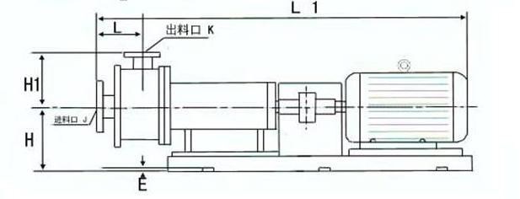
SRH High-shear Emulsifying Pump：

Model | L | L1 | H | H1 | E | J Ø | K Ø
SRH-60 | 90 | 575 | 180 | 150 | 12 | 38 | 32
SRH -80 | 90 | 575 | 180 | 150 | 12 | 38 | 32
SRH-100 | 90 | 575 | 180 | 150 | 12 | 38 | 32
SRH -130 | 137 | 743 | 224 | 182 | 12 | 51 | 38
SRH -140 | 137 | 743 | 225 | 182 | 12 | 51 | 38
SRH -165 | 137 | 743 | 225 | 182 | 12 | 51 | 38
SRH -180 | 142 | 864 | 250 | 190 | 12 | 63.5 | 51
SRH -190 | 142 | 916 | 250 | 190 | 12 | 63.5 | 51
SRH -200 | 142 | 986 | 270 | 190 | 16 | 63.5 | 51
SRH -210 | 150 | 1400 | 300 | 230 | 16 | 76 | 63.5
SRH -230 | 150 | 1485 | 325 | 240 | 16 | 102 | 76

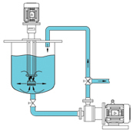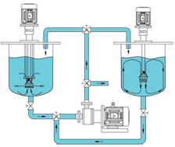

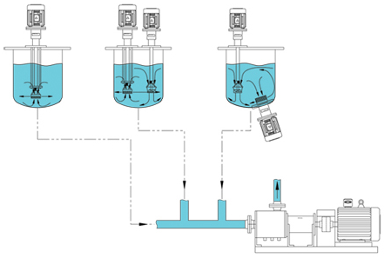

SRH Series High-Shear Emulsifier Function Table
Model | Power/KW | Speed/rpm | Flow range m3/h | n-d
SRH-60 | 1.1 | 2800-2900 | 0-1 | 4-Φ14
SRH -80 | 1.5 | 2800-2900 | 0-1.5 | 4-Φ14
SRH -100 | 2.2 | 2800-2900 | 0-3 | 4-Φ14
SRH -130 | 4 | 2800-2900 | 0-4 | 4-Φ14
SRH -140 | 5.5 | 2800-2900 | 0-5 | 4-Φ14
SRH -165 | 7.5 | 2800-2900 | 0-8 | 4-Φ14
SRH -180 | 11 | 2800-2900 | 0-12 | 4-Φ14
SRH -190 | 15 | 2800-2900 | 0-20 | 4-Φ14
SRH -200 | 22 | 2800-2900 | 0-25 | 4-Φ20
SRH -210 | 30 | 2800-2900 | 0-35 | 6-Φ20
SRH -230 | 45 | 2800-2900 | 0-50 | 6-Φ20

