TP420xp System Configuration & Specifications

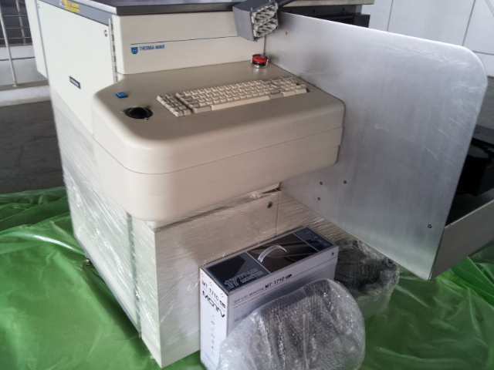

The Therma-Probe® is the industry standard for implant dose metrology. With its advances in modulated optical reflectance, the Therma-Probe system provides dose measurements for in-line ion implantation monitoring. The system contributes to higher yield by monitoring for process excursions

The Therma-Probe model TP420xp uses a laser-based, noncontact, nondestructive measurement technique for monitoring ion implantation and other processes. The standard configuration includes: automatic thermal wave measurement system for implants with doses from 1x1011 to 2x1016 ions/cm2 and energies from 5 keV to 3 MeV.

The thickness of any oxide over the implanted area is automatically measured at the same time as the dose measurement. The measurement system uses two lasers HeNe 670 nm and a high power 10 mw Argon Laser 740 nm to: (1) induce modulated thermal and plasma waves into the substrate; and (2) monitor the resulting modulated reflectance signal. The measurement system also includes a precision x-y-theta stage with centering and flat/notch finding capabilities and a high speed autofocus system for the 0.9 micron measurement spot.

A temperature control system is used to maintain high measurement repeatability. Fully integrated wafer handling system with automated random access robotic wafer handler and two cassette stations (one for the measurement of Silicon Calibration Wafers). The system is capable of handling SEMI standard 100 to 200 mm wafers.
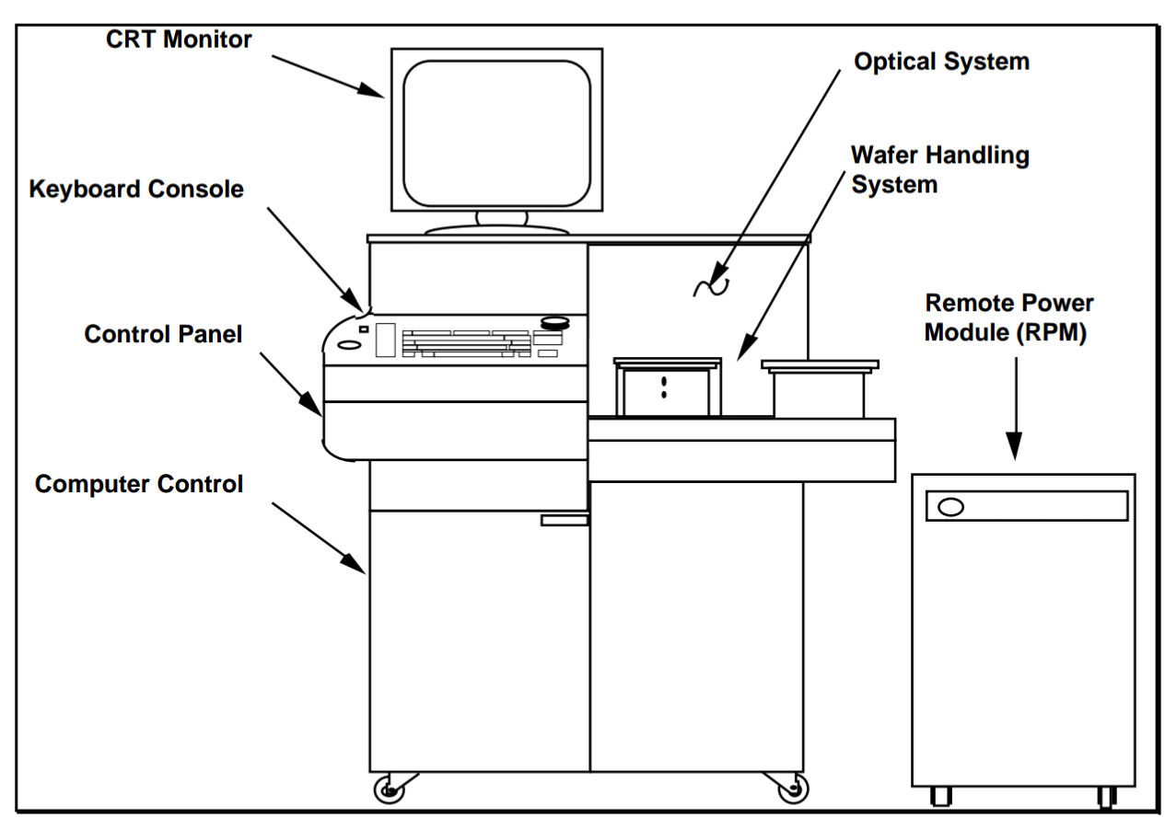
System Overview
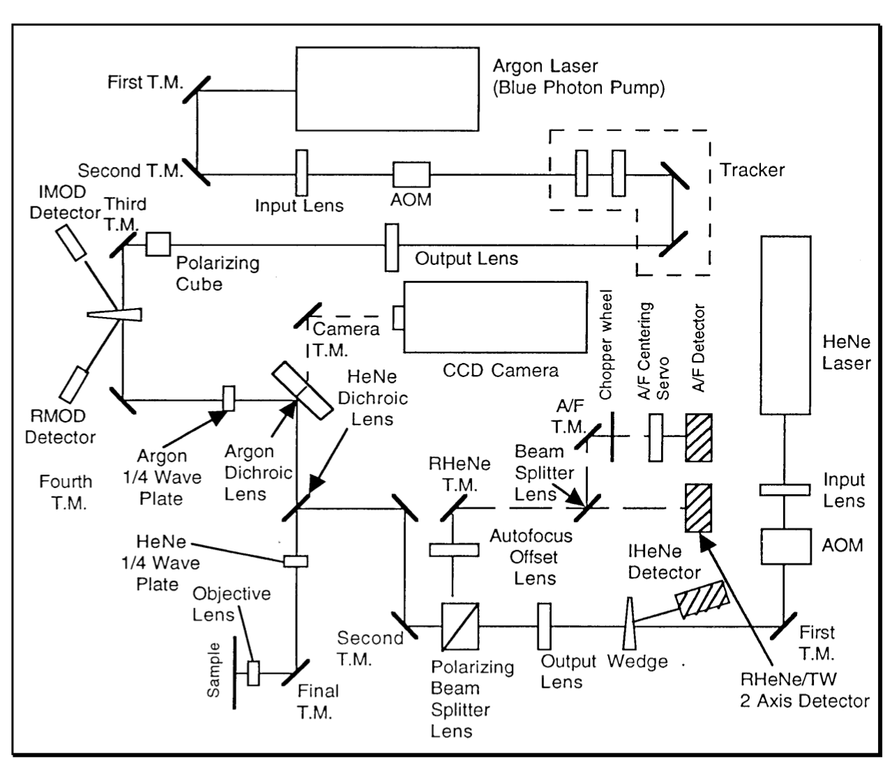
Optical Overview
